МИНИСТЕРСТВО НАУКИ И ВЫСШЕГО ОБРАЗОВАНИЯ РФ ФЕДЕРАЛЬНОЕ ГОСУДАРСТВЕННОЕ БЮДЖЕТНОЕ ОБРАЗОВАТЕЛЬНОЕ УЧРЕЖДЕНИЕ ВЫСШЕГО ОБРАЗОВАНИЯ **«БЕЛГОРОДСКИЙ ГОСУДАРСТВЕННЫЙ ТЕХНОЛОГИЧЕСКИЙ УНИВЕРСИТЕТ им. В. Г. ШУХОВА» (БГТУ им. В.Г. Шухова)**

Кафедра программного обеспечения вычислительной техники и автоматизированных систем

Расчетно-графическое задание

Дисциплина: Технологии web-программирования

Тема: “Веб-приложение для продажи автомобилей”

Выполнил: Шошин Олег ПВ-42

Проверил: Картамышев С. В.

Белгород 2020г.

Оглавление

Оглавление 2

Цель работы 3

Разработка макетов и верстка шаблонов с помощью HTML и CSS 4

Использование фронтенд-фреймворка. VueJS. 43

Проектирование БД 51

Создание БД. 52

Создание REST API 63

Вывод: 78

# Цель работы

Целью проекта является разработка веб-приложения для продажи автомобилей. Для реализации поставленной задачи необходимо разработать макет и сделать верстку страниц по макетам и перенести верстку на компоненты фронтенд-фреймворка. Был выбран VueJS. Также нужно было разработать бэкенд, что включает в себя создание REST API и проектирование БД.

Функционал приложения: пользователь может просматривать объявления автомобилей.

# Разработка макетов и верстка шаблонов с помощью HTML и CSS

За основу для разработки шаблона был взят сайт auto.ru.

Были разработаны 4 страницы – главная, страница поиска легковых автомобилей, страница описания автомобиля, страница профиля пользователя.

В разработке были задействованы инструменты Bootstrap.

**Описание страниц**

1. Главная страница

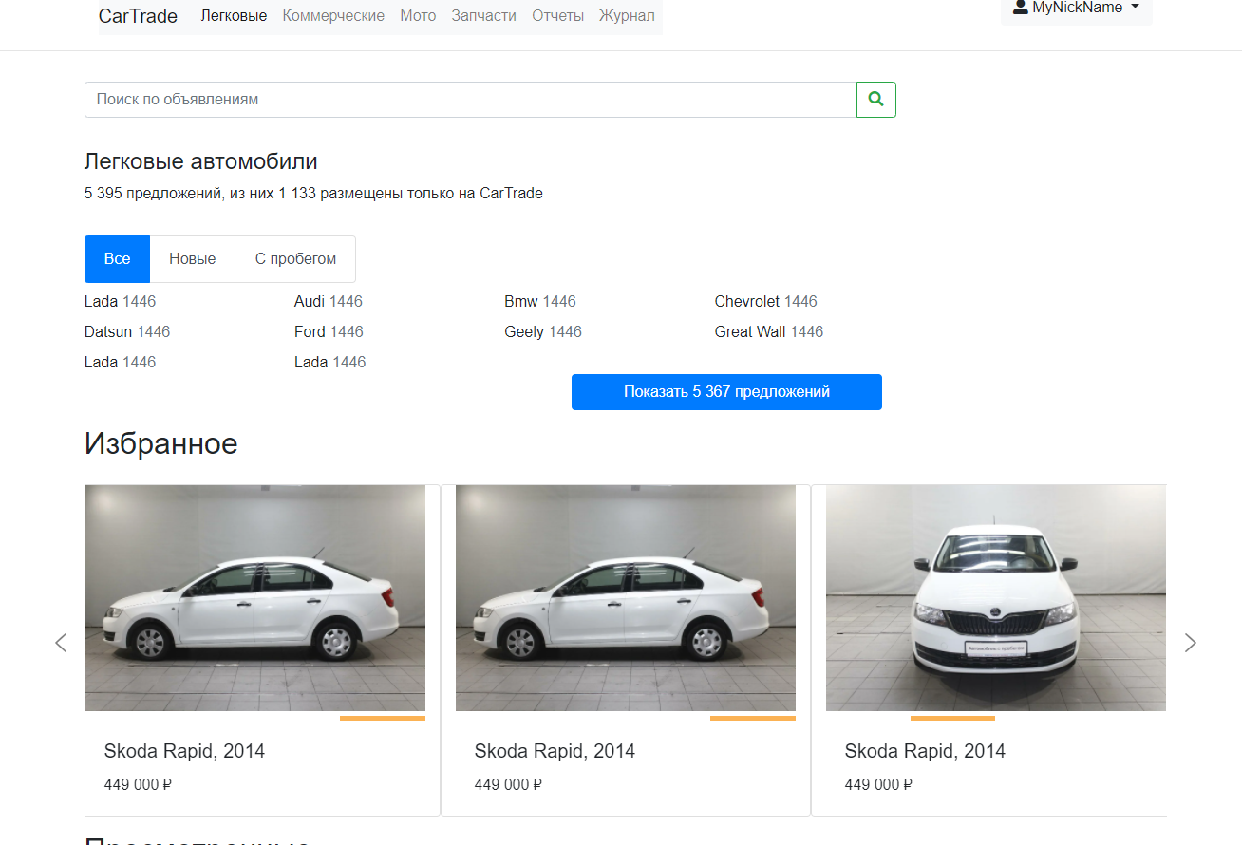

Содержит общее для всех страниц меню навигации, поле поиска автомобиля по названию, блок выбора автомобиля по марке, блок с каруселью, в которой отображаются блоки с краткой информацией об автомобили. Блоки с краткой информацией об автомобиле в свою очередь содержат карусель с изображениями автомобиля, причем карусель прокручивается при перемещении курсора мыши по горизонтали.

1. Страница поиска легковых автомобилей

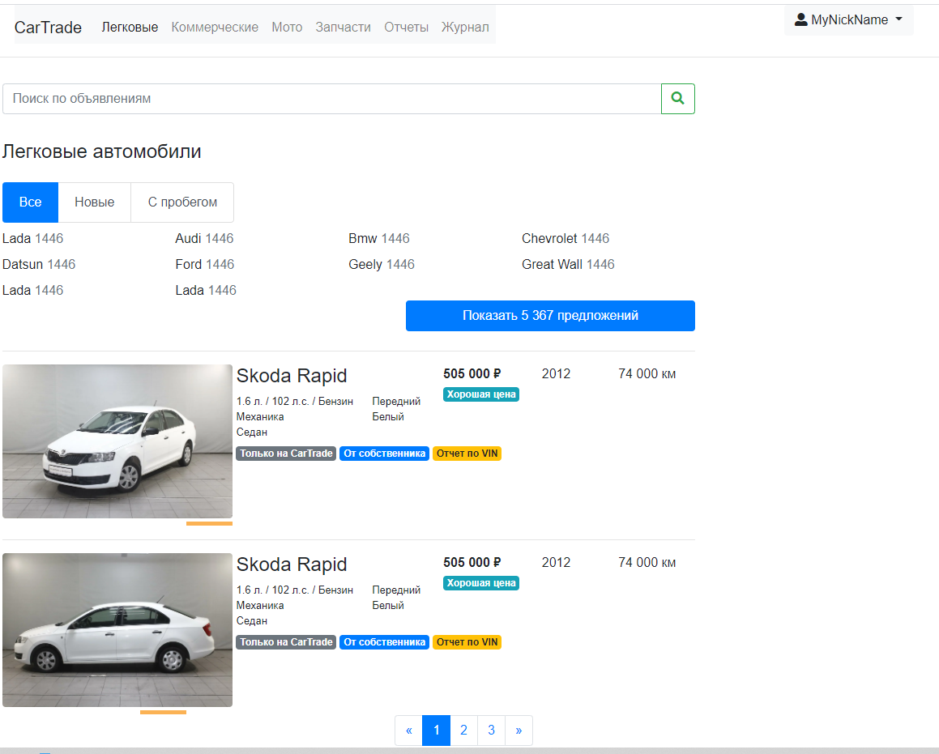

Страница включает блок навигации, блок поиска автомобиля, блок выбора автомобиля по марке, блок со списком блоков, представляющих блок с информацией об автомобиле.

1. Страница с полным описанием автомобиля.

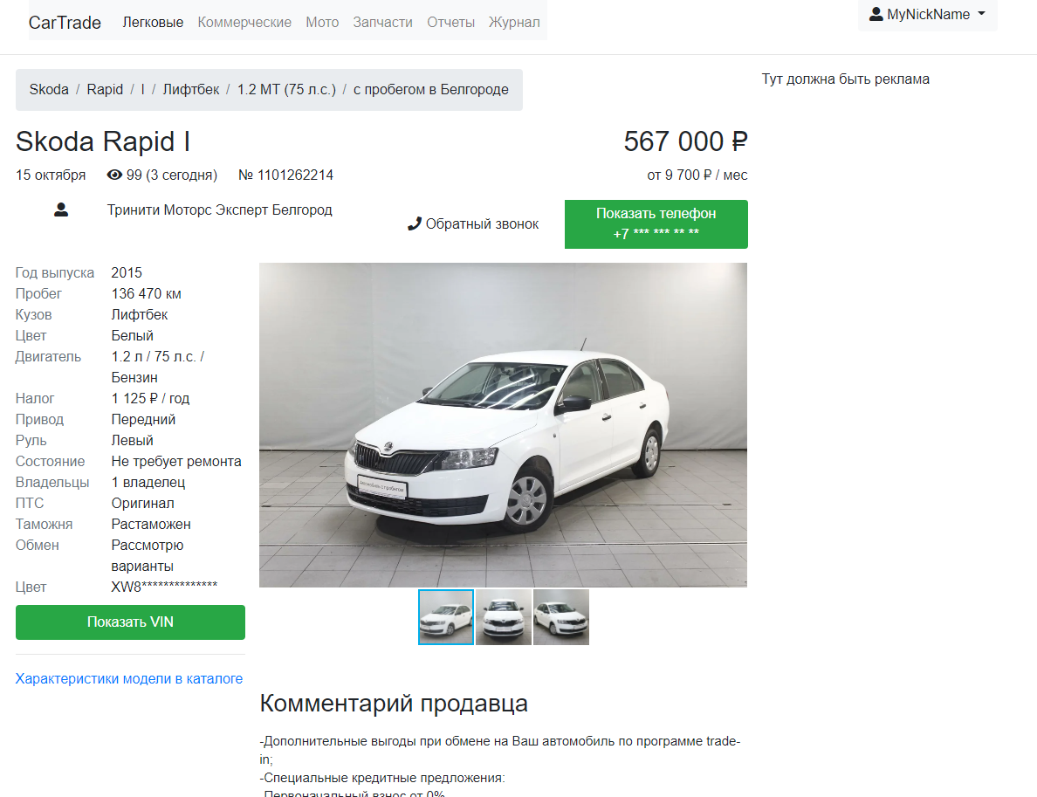

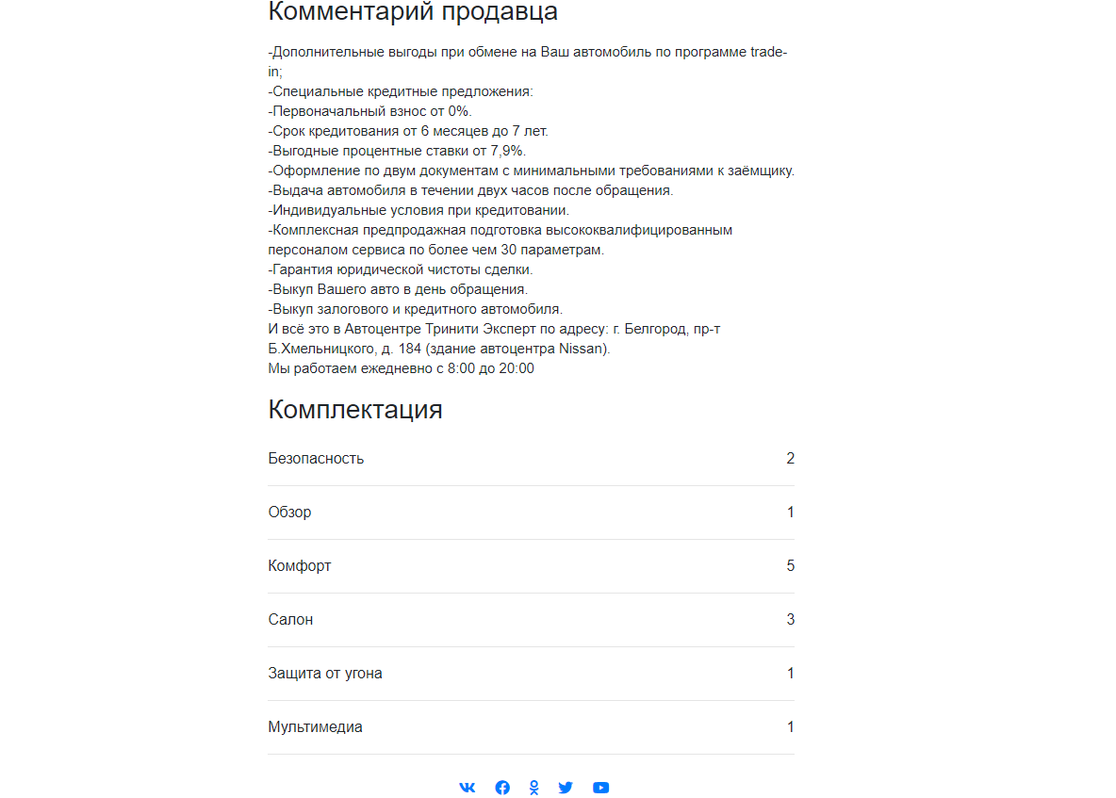

Содержит блок меню навигации, блок описания технических характеристик автомобиля, блок с каруселью для просмотра изображения автомобиля, блок комментариев продавца, блок комплектации, содержащий выпадающие списки по отдельным категориям элементов комплектации.

1. Страница профиля пользователя

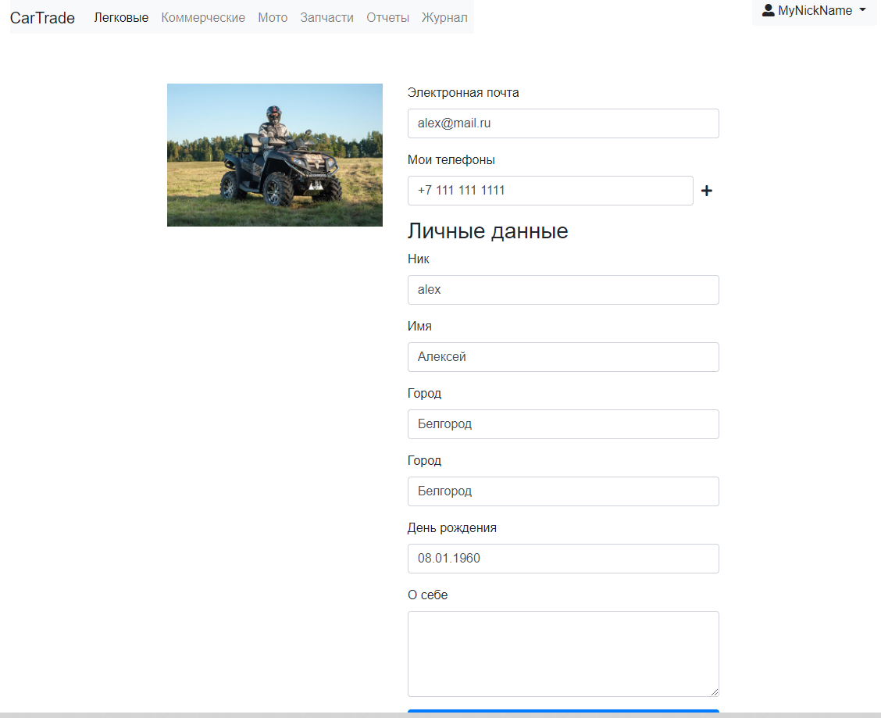

index.html

<!doctype *html*>

<html *lang*="en">

  <head>

*<!-- Required meta tags -->*

    <meta *charset*="utf-8">

    <meta *name*="viewport" *content*="width=device-width, initial-scale=1, shrink-to-fit=no">

*<!-- Font Awesome -->*

    <link *rel*="stylesheet" *href*="https://use.fontawesome.com/releases/v5.11.2/css/all.css">

*<!-- Bootstrap CSS -->*

    <link *rel*="stylesheet" *href*="https://cdn.jsdelivr.net/npm/bootstrap@4.5.3/dist/css/bootstrap.min.css" *integrity*="sha384-TX8t27EcRE3e/ihU7zmQxVncDAy5uIKz4rEkgIXeMed4M0jlfIDPvg6uqKI2xXr2" *crossorigin*="anonymous">

    <link *rel*="stylesheet" *href*="css/styles.css">

    <link *rel*="stylesheet" *href*="css/jQuery.Brazzers-Carousel.min.css">

    <title> Car </title>

  </head>

  <body>

  <header *class*="mainHeader">

    <div *class*="container py-0 d-flex justify-content-between">

      <nav *class*="navbar navbar-expand-lg navbar-light bg-light px-0 pb-0">

        <a *class*="navbar-brand" *href*="index.html">CarTrade</a>

        <button *class*="navbar-toggler" *type*="button" *data-toggle*="collapse" *data-target*="#navbarSupportedContent" *aria-controls*="navbarSupportedContent" *aria-expanded*="false" *aria-label*="Toggle navigation">

          <span *class*="navbar-toggler-icon"></span>

        </button>

        <div *class*="collapse navbar-collapse" *id*="navbarSupportedContent">

          <ul *class*="navbar-nav mr-auto">

            <li *class*="nav-item active">

              <a *class*="nav-link" *href*="car.html">Легковые <span *class*="sr-only">(current)</span></a>

            </li>

            <li *class*="nav-item">

              <a *class*="nav-link" *href*="#">Коммерческие</a>

            </li>

            <li *class*="nav-item">

              <a *class*="nav-link" *href*="#">Мото</a>

            </li>

            <li *class*="nav-item">

              <a *class*="nav-link" *href*="#">Запчасти</a>

            </li>

            <li *class*="nav-item">

              <a *class*="nav-link" *href*="#">Отчеты</a>

            </li>

            <li *class*="nav-item">

              <a *class*="nav-link" *href*="#">Журнал</a>

            </li>

          </ul>

      </nav>

      <div *class*="dropdown">

        <button *class*="btn btn-light dropdown-toggle" *type*="button" *id*="dropdownMenu2" *data-toggle*="dropdown" *aria-haspopup*="true" *aria-expanded*="false">

          <i *class*="fas fa-user-alt"></i> MyNickName

        </button>

        <div *class*="dropdown-menu" *aria-labelledby*="dropdownMenu2">

          <a *class*="dropdown-item" *href*="profile.html">Настройки</a>

          <a *class*="dropdown-item" *href*="#">Объявления</a>

          <a *class*="dropdown-item" *href*="#">Отзывы</a>

        </div>

      </div>

    </div>

  </div>

  </header>

  <main>

    <section>

      <hr *claass*="py-0">

      <div *class*="container">

        <div *class*="row pt-3"> *<!--search cars-->*

          <div *class*="col-9">

            <div *class*="row">

              <div *class*="input-group mb-3">

                <input *class*="form-control" *type*="search" *placeholder*="Поиск по объявлениям" *aria-label*="Search" *aria-describedby*="buttonSearch">

                <div *class*="input-group-append">

                  <button *class*="btn btn-outline-success" *type*="button" *id*="buttonSearch">

                    <i *class*="fas fa-search"></i>

                  </button>

                </div>

              </div>

            </div>

            <div *class*="row">

              <div *class*="col-12 pt-3 px-0">

                <h4 >Легковые автомобили</h4>

                <p>5 395 предложений, из них 1 133 размещены только на CarTrade</p>

              </div>

            </div>

            <div *class*="row pt-3">

              <div *class*="list-group list-group-horizontal " *id*="usedStatusListTab" *role*="tablist">

                <a *class*="list-group-item list-group-item-action active" *id*="usedStatusTab-all" *data-toggle*="list" *href*="#usedStatusTabContent-all" *role*="tab">Все</a>

                <a *class*="list-group-item list-group-item-action" *id*="usedStatusTab-new" *data-toggle*="list" *href*="#usedStatusTabContent-new" *role*="tab">Новые</a>

                <a *class*="list-group-item list-group-item-action" *id*="usedStatusTab-used" *data-toggle*="list" *href*="#usedStatusTabContent-used" *role*="tab">С пробегом</a>

              </div>

            </div>

            <div *class*="row">

              <div *class*="col-12 px-0">

                <div *class*="tab-content" *id*="nav-tabContent">

                  <div *class*="tab-pane fade show active" *id*="usedStatusTabContent-all" *role*="tabpanel" *aria-labelledby*="usedStatusTab-all">

                    <div *class*="row">

                      <div *class*="col-3 pt-2"> Lada <span *class*="text-muted">1446</span> </div>

                      <div *class*="col-3 pt-2"> Audi <span *class*="text-muted">1446</span> </div>

                      <div *class*="col-3 pt-2"> Bmw <span *class*="text-muted">1446</span> </div>

                      <div *class*="col-3 pt-2"> Chevrolet <span *class*="text-muted">1446</span> </div>

                      <div *class*="col-3 pt-2"> Datsun <span *class*="text-muted">1446</span> </div>

                      <div *class*="col-3 pt-2"> Ford <span *class*="text-muted">1446</span> </div>

                      <div *class*="col-3 pt-2"> Geely <span *class*="text-muted">1446</span> </div>

                      <div *class*="col-3 pt-2"> Great Wall <span *class*="text-muted">1446</span> </div>

                      <div *class*="col-3 pt-2"> Lada <span *class*="text-muted">1446</span> </div>

                      <div *class*="col-3 pt-2"> Lada <span *class*="text-muted">1446</span> </div>

                    </div>

                  </div>

                  <div *class*="tab-pane fade " *id*="usedStatusTabContent-new" *role*="tabpanel" *aria-labelledby*="usedStatusTab-new">

                    <div *class*="row">

                      <div *class*="col-3 pt-2"> Lada <span *class*="text-muted">1446</span> </div>

                      <div *class*="col-3 pt-2"> Audi <span *class*="text-muted">1446</span> </div>

                      <div *class*="col-3 pt-2"> Bmw <span *class*="text-muted">1446</span> </div>

                      <div *class*="col-3 pt-2"> Chevrolet <span *class*="text-muted">1446</span> </div>

                      <div *class*="col-3 pt-2"> Datsun <span *class*="text-muted">1446</span> </div>

                      <div *class*="col-3 pt-2"> Ford <span *class*="text-muted">1446</span> </div>

                      <div *class*="col-3 pt-2"> Geely <span *class*="text-muted">1446</span> </div>

                      <div *class*="col-3 pt-2"> Great Wall <span *class*="text-muted">1446</span> </div>

                      <div *class*="col-3 pt-2"> Lada <span *class*="text-muted">1446</span> </div>

                      <div *class*="col-3 pt-2"> Lada <span *class*="text-muted">1446</span> </div>

                    </div>

                  </div>

                  <div *class*="tab-pane fade" *id*="usedStatusTabContent-used" *role*="tabpanel" *aria-labelledby*="usedStatusTab-used">

                    <div *class*="row">

                      <div *class*="col-3 pt-2"> Lada <span *class*="text-muted">1446</span> </div>

                      <div *class*="col-3 pt-2"> Audi <span *class*="text-muted">1446</span> </div>

                      <div *class*="col-3 pt-2"> Bmw <span *class*="text-muted">1446</span> </div>

                      <div *class*="col-3 pt-2"> Chevrolet <span *class*="text-muted">1446</span> </div>

                      <div *class*="col-3 pt-2"> Datsun <span *class*="text-muted">1446</span> </div>

                      <div *class*="col-3 pt-2"> Ford <span *class*="text-muted">1446</span> </div>

                      <div *class*="col-3 pt-2"> Geely <span *class*="text-muted">1446</span> </div>

                      <div *class*="col-3 pt-2"> Great Wall <span *class*="text-muted">1446</span> </div>

                      <div *class*="col-3 pt-2"> Lada <span *class*="text-muted">1446</span> </div>

                      <div *class*="col-3 pt-2"> Lada <span *class*="text-muted">1446</span> </div>

                    </div>

                  </div>

                </div>

              </div>

            </div>

            <div *class*="row">

              <div *class*="col-7">

              </div>

              <div *class*="col-5">

                <button *class*="btn btn-primary w-100">Показать 5 367 предложений</button>

              </div>

            </div>

          </div>

        </div>

      </div>

    </section>

    <section>

      <div *class*="container pt-3 px-0">

        <h2>Избранное</h2>

        <div *id*="carouselExampleControls" *class*="carousel slide" *data-wrap*="false" *data-ride*="carousel" *data-interval*="false">

          <div *class*="carousel-inner">

            <div *class*="carousel-item active">

              <div *class*="row pt-3">

                <div *class*="card col-md-4 col-sm-6 col-xs-12">

                  <div *class*="thumb-item card-img-top">

                    <img *class*="rouned" *src*="assets/img/imgCars/SkodaRapid/SkodaRapid1.webp" *alt*="Alt">

                    <img *class*="rouned" *src*="assets/img/imgCars/SkodaRapid/SkodaRapid2.webp" *alt*="Alt">

                    <img *class*="rouned" *src*="assets/img/imgCars/SkodaRapid/SkodaRapid3.webp" *alt*="Alt">

                    <img *class*="rouned" *src*="assets/img/imgCars/SkodaRapid/SkodaRapid4.webp" *alt*="Alt">

                  </div>

                  <div *class*="card-body">

                    <h5 *class*="card-title">Skoda Rapid, 2014</h5>

                    <p *class*="card-text">449 000 ₽</p>

                  </div>

                </div>

                <div *class*="card col-md-4 col-sm-6 col-xs-12">

                  <div *class*="thumb-item card-img-top">

                    <img *class*="rouned" *src*="assets/img/imgCars/SkodaRapid/SkodaRapid1.webp" *alt*="Alt">

                    <img *class*="rouned" *src*="assets/img/imgCars/SkodaRapid/SkodaRapid2.webp" *alt*="Alt">

                    <img *class*="rouned" *src*="assets/img/imgCars/SkodaRapid/SkodaRapid3.webp" *alt*="Alt">

                    <img *class*="rouned" *src*="assets/img/imgCars/SkodaRapid/SkodaRapid4.webp" *alt*="Alt">

                  </div>

                  <div *class*="card-body">

                    <h5 *class*="card-title">Skoda Rapid, 2014</h5>

                    <p *class*="card-text">449 000 ₽</p>

                  </div>

                </div>

                <div *class*="card col-md-4 col-sm-6 col-xs-12">

                  <div *class*="thumb-item card-img-top">

                    <img *class*="rouned" *src*="assets/img/imgCars/SkodaRapid/SkodaRapid1.webp" *alt*="Alt">

                    <img *class*="rouned" *src*="assets/img/imgCars/SkodaRapid/SkodaRapid2.webp" *alt*="Alt">

                    <img *class*="rouned" *src*="assets/img/imgCars/SkodaRapid/SkodaRapid3.webp" *alt*="Alt">

                    <img *class*="rouned" *src*="assets/img/imgCars/SkodaRapid/SkodaRapid4.webp" *alt*="Alt">

                  </div>

                  <div *class*="card-body">

                    <h5 *class*="card-title">Skoda Rapid, 2014</h5>

                    <p *class*="card-text">449 000 ₽</p>

                  </div>

                </div>

              </div>

            </div>

            <div *class*="carousel-item">

              <div *class*="row pt-3">

                <div *class*="card col-md-4 col-sm-6 col-xs-12">

                  <div *class*="thumb-item card-img-top">

                    <img *src*="assets/img/imgCars/SkodaRapid/SkodaRapid1.webp" *alt*="Alt">

                    <img *src*="assets/img/imgCars/SkodaRapid/SkodaRapid2.webp" *alt*="Alt">

                    <img *src*="assets/img/imgCars/SkodaRapid/SkodaRapid3.webp" *alt*="Alt">

                    <img *src*="assets/img/imgCars/SkodaRapid/SkodaRapid4.webp" *alt*="Alt">

                  </div>

                  <div *class*="card-body">

                    <h5 *class*="card-title">Skoda Rapid, 2014</h5>

                    <p *class*="card-text">449 000 ₽</p>

                  </div>

                </div>

                <div *class*="card col-md-4 col-sm-6 col-xs-12">

                  <div *class*="thumb-item card-img-top">

                    <img *src*="assets/img/imgCars/SkodaRapid/SkodaRapid1.webp" *alt*="Alt">

                    <img *src*="assets/img/imgCars/SkodaRapid/SkodaRapid2.webp" *alt*="Alt">

                    <img *src*="assets/img/imgCars/SkodaRapid/SkodaRapid3.webp" *alt*="Alt">

                    <img *src*="assets/img/imgCars/SkodaRapid/SkodaRapid4.webp" *alt*="Alt">

                  </div>

                  <div *class*="card-body">

                    <h5 *class*="card-title">Skoda Rapid, 2014</h5>

                    <p *class*="card-text">449 000 ₽</p>

                  </div>

                </div>

                <div *class*="card col-md-4 col-sm-6 col-xs-12">

                  <div *class*="thumb-item card-img-top">

                    <img *src*="assets/img/imgCars/SkodaRapid/SkodaRapid1.webp" *alt*="Alt">

                    <img *src*="assets/img/imgCars/SkodaRapid/SkodaRapid2.webp" *alt*="Alt">

                    <img *src*="assets/img/imgCars/SkodaRapid/SkodaRapid3.webp" *alt*="Alt">

                    <img *src*="assets/img/imgCars/SkodaRapid/SkodaRapid4.webp" *alt*="Alt">

                  </div>

                  <div *class*="card-body">

                    <h5 *class*="card-title">Skoda Rapid, 2014</h5>

                    <p *class*="card-text">449 000 ₽</p>

                  </div>

                </div>

              </div>

            </div>

            <div *class*="carousel-item">

              <div *class*="row pt-3">

                <div *class*="card col-md-4 col-sm-6 col-xs-12">

                  <div *class*="thumb-item card-img-top">

                    <img *src*="assets/img/imgCars/SkodaRapid/SkodaRapid1.webp" *alt*="Alt">

                    <img *src*="assets/img/imgCars/SkodaRapid/SkodaRapid2.webp" *alt*="Alt">

                    <img *src*="assets/img/imgCars/SkodaRapid/SkodaRapid3.webp" *alt*="Alt">

                    <img *src*="assets/img/imgCars/SkodaRapid/SkodaRapid4.webp" *alt*="Alt">

                  </div>

                  <div *class*="card-body">

                    <h5 *class*="card-title">Skoda Rapid, 2014</h5>

                    <p *class*="card-text">449 000 ₽</p>

                  </div>

                </div>

                <div *class*="card col-md-4 col-sm-6 col-xs-12">

                  <div *class*="thumb-item card-img-top">

                    <img *src*="assets/img/imgCars/SkodaRapid/SkodaRapid1.webp" *alt*="Alt">

                    <img *src*="assets/img/imgCars/SkodaRapid/SkodaRapid2.webp" *alt*="Alt">

                    <img *src*="assets/img/imgCars/SkodaRapid/SkodaRapid3.webp" *alt*="Alt">

                    <img *src*="assets/img/imgCars/SkodaRapid/SkodaRapid4.webp" *alt*="Alt">

                  </div>

                  <div *class*="card-body">

                    <h5 *class*="card-title">Skoda Rapid, 2014</h5>

                    <p *class*="card-text">449 000 ₽</p>

                  </div>

                </div>

                <div *class*="card col-md-4 col-sm-6 col-xs-12">

                  <div *class*="thumb-item card-img-top">

                    <img *src*="assets/img/imgCars/SkodaRapid/SkodaRapid1.webp" *alt*="Alt">

                    <img *src*="assets/img/imgCars/SkodaRapid/SkodaRapid2.webp" *alt*="Alt">

                    <img *src*="assets/img/imgCars/SkodaRapid/SkodaRapid3.webp" *alt*="Alt">

                    <img *src*="assets/img/imgCars/SkodaRapid/SkodaRapid4.webp" *alt*="Alt">

                  </div>

                  <div *class*="card-body">

                    <h5 *class*="card-title">Skoda Rapid, 2014</h5>

                    <p *class*="card-text">449 000 ₽</p>

                  </div>

                </div>

              </div>

            </div>

          </div>

          <a *class*="carousel-control-prev" *href*="#carouselExampleControls" *role*="button" *data-slide*="prev">

            <span *class*="carousel-control-prev-icon" *aria-hidden*="true"></span>

            <span *class*="sr-only">Previous</span>

          </a>

          <a *class*="carousel-control-next" *href*="#carouselExampleControls" *role*="button" *data-slide*="next">

            <span *class*="carousel-control-next-icon" *aria-hidden*="true"></span>

            <span *class*="sr-only">Next</span>

          </a>

        </div>

      </div>

      <div *class*="container pt-3 px-0">

        <h2>Просмотренные</h2>

        <div *id*="carouselExampleControls" *class*="carousel slide" *data-wrap*="false" *data-ride*="carousel" *data-interval*="false">

          <div *class*="carousel-inner">

            <div *class*="carousel-item active">

              <div *class*="row pt-3">

                <div *class*="card col-md-4 col-sm-6 col-xs-12">

                  <div *class*="thumb-item card-img-top">

                    <img *class*="rouned" *src*="assets/img/imgCars/SkodaRapid/SkodaRapid1.webp" *alt*="Alt">

                    <img *class*="rouned" *src*="assets/img/imgCars/SkodaRapid/SkodaRapid2.webp" *alt*="Alt">

                    <img *class*="rouned" *src*="assets/img/imgCars/SkodaRapid/SkodaRapid3.webp" *alt*="Alt">

                    <img *class*="rouned" *src*="assets/img/imgCars/SkodaRapid/SkodaRapid4.webp" *alt*="Alt">

                  </div>

                  <div *class*="card-body">

                    <h5 *class*="card-title">Skoda Rapid, 2014</h5>

                    <p *class*="card-text">449 000 ₽</p>

                  </div>

                </div>

                <div *class*="card col-md-4 col-sm-6 col-xs-12">

                  <div *class*="thumb-item card-img-top">

                    <img *class*="rouned" *src*="assets/img/imgCars/SkodaRapid/SkodaRapid1.webp" *alt*="Alt">

                    <img *class*="rouned" *src*="assets/img/imgCars/SkodaRapid/SkodaRapid2.webp" *alt*="Alt">

                    <img *class*="rouned" *src*="assets/img/imgCars/SkodaRapid/SkodaRapid3.webp" *alt*="Alt">

                    <img *class*="rouned" *src*="assets/img/imgCars/SkodaRapid/SkodaRapid4.webp" *alt*="Alt">

                  </div>

                  <div *class*="card-body">

                    <h5 *class*="card-title">Skoda Rapid, 2014</h5>

                    <p *class*="card-text">449 000 ₽</p>

                  </div>

                </div>

                <div *class*="card col-md-4 col-sm-6 col-xs-12">

                  <div *class*="thumb-item card-img-top">

                    <img *class*="rouned" *src*="assets/img/imgCars/SkodaRapid/SkodaRapid1.webp" *alt*="Alt">

                    <img *class*="rouned" *src*="assets/img/imgCars/SkodaRapid/SkodaRapid2.webp" *alt*="Alt">

                    <img *class*="rouned" *src*="assets/img/imgCars/SkodaRapid/SkodaRapid3.webp" *alt*="Alt">

                    <img *class*="rouned" *src*="assets/img/imgCars/SkodaRapid/SkodaRapid4.webp" *alt*="Alt">

                  </div>

                  <div *class*="card-body">

                    <h5 *class*="card-title">Skoda Rapid, 2014</h5>

                    <p *class*="card-text">449 000 ₽</p>

                  </div>

                </div>

              </div>

            </div>

            <div *class*="carousel-item">

              <div *class*="row pt-3">

                <div *class*="card col-md-4 col-sm-6 col-xs-12">

                  <div *class*="thumb-item card-img-top">

                    <img *src*="assets/img/imgCars/SkodaRapid/SkodaRapid1.webp" *alt*="Alt">

                    <img *src*="assets/img/imgCars/SkodaRapid/SkodaRapid2.webp" *alt*="Alt">

                    <img *src*="assets/img/imgCars/SkodaRapid/SkodaRapid3.webp" *alt*="Alt">

                    <img *src*="assets/img/imgCars/SkodaRapid/SkodaRapid4.webp" *alt*="Alt">

                  </div>

                  <div *class*="card-body">

                    <h5 *class*="card-title">Skoda Rapid, 2014</h5>

                    <p *class*="card-text">449 000 ₽</p>

                  </div>

                </div>

                <div *class*="card col-md-4 col-sm-6 col-xs-12">

                  <div *class*="thumb-item card-img-top">

                    <img *src*="assets/img/imgCars/SkodaRapid/SkodaRapid1.webp" *alt*="Alt">

                    <img *src*="assets/img/imgCars/SkodaRapid/SkodaRapid2.webp" *alt*="Alt">

                    <img *src*="assets/img/imgCars/SkodaRapid/SkodaRapid3.webp" *alt*="Alt">

                    <img *src*="assets/img/imgCars/SkodaRapid/SkodaRapid4.webp" *alt*="Alt">

                  </div>

                  <div *class*="card-body">

                    <h5 *class*="card-title">Skoda Rapid, 2014</h5>

                    <p *class*="card-text">449 000 ₽</p>

                  </div>

                </div>

                <div *class*="card col-md-4 col-sm-6 col-xs-12">

                  <div *class*="thumb-item card-img-top">

                    <img *src*="assets/img/imgCars/SkodaRapid/SkodaRapid1.webp" *alt*="Alt">

                    <img *src*="assets/img/imgCars/SkodaRapid/SkodaRapid2.webp" *alt*="Alt">

                    <img *src*="assets/img/imgCars/SkodaRapid/SkodaRapid3.webp" *alt*="Alt">

                    <img *src*="assets/img/imgCars/SkodaRapid/SkodaRapid4.webp" *alt*="Alt">

                  </div>

                  <div *class*="card-body">

                    <h5 *class*="card-title">Skoda Rapid, 2014</h5>

                    <p *class*="card-text">449 000 ₽</p>

                  </div>

                </div>

              </div>

            </div>

            <div *class*="carousel-item">

              <div *class*="row pt-3">

                <div *class*="card col-md-4 col-sm-6 col-xs-12">

                  <div *class*="thumb-item card-img-top">

                    <img *src*="assets/img/imgCars/SkodaRapid/SkodaRapid1.webp" *alt*="Alt">

                    <img *src*="assets/img/imgCars/SkodaRapid/SkodaRapid2.webp" *alt*="Alt">

                    <img *src*="assets/img/imgCars/SkodaRapid/SkodaRapid3.webp" *alt*="Alt">

                    <img *src*="assets/img/imgCars/SkodaRapid/SkodaRapid4.webp" *alt*="Alt">

                  </div>

                  <div *class*="card-body">

                    <h5 *class*="card-title">Skoda Rapid, 2014</h5>

                    <p *class*="card-text">449 000 ₽</p>

                  </div>

                </div>

                <div *class*="card col-md-4 col-sm-6 col-xs-12">

                  <div *class*="thumb-item card-img-top">

                    <img *src*="assets/img/imgCars/SkodaRapid/SkodaRapid1.webp" *alt*="Alt">

                    <img *src*="assets/img/imgCars/SkodaRapid/SkodaRapid2.webp" *alt*="Alt">

                    <img *src*="assets/img/imgCars/SkodaRapid/SkodaRapid3.webp" *alt*="Alt">

                    <img *src*="assets/img/imgCars/SkodaRapid/SkodaRapid4.webp" *alt*="Alt">

                  </div>

                  <div *class*="card-body">

                    <h5 *class*="card-title">Skoda Rapid, 2014</h5>

                    <p *class*="card-text">449 000 ₽</p>

                  </div>

                </div>

                <div *class*="card col-md-4 col-sm-6 col-xs-12">

                  <div *class*="thumb-item card-img-top">

                    <img *src*="assets/img/imgCars/SkodaRapid/SkodaRapid1.webp" *alt*="Alt">

                    <img *src*="assets/img/imgCars/SkodaRapid/SkodaRapid2.webp" *alt*="Alt">

                    <img *src*="assets/img/imgCars/SkodaRapid/SkodaRapid3.webp" *alt*="Alt">

                    <img *src*="assets/img/imgCars/SkodaRapid/SkodaRapid4.webp" *alt*="Alt">

                  </div>

                  <div *class*="card-body">

                    <h5 *class*="card-title">Skoda Rapid, 2014</h5>

                    <p *class*="card-text">449 000 ₽</p>

                  </div>

                </div>

              </div>

            </div>

          </div>

          <a *class*="carousel-control-prev" *href*="#carouselExampleControls" *role*="button" *data-slide*="prev">

            <span *class*="carousel-control-prev-icon" *aria-hidden*="true"></span>

            <span *class*="sr-only">Previous</span>

          </a>

          <a *class*="carousel-control-next" *href*="#carouselExampleControls" *role*="button" *data-slide*="next">

            <span *class*="carousel-control-next-icon" *aria-hidden*="true"></span>

            <span *class*="sr-only">Next</span>

          </a>

        </div>

      </div>

    </section>

  </main>

  <footer *class*="text-center mt-4 wow fadeIn">

    <a *href*="#">

      <i *class*="fab fa-vk mr-3"></i>

    </a>

    <a *href*="#">

      <i *class*="fab fa-facebook mr-3"></i>

    </a>

    <a *href*="#">

      <i *class*="fab fa-odnoklassniki mr-3"></i>

    </a>

    <a *href*="#">

      <i *class*="fab fa-twitter mr-3"></i>

    </a>

    <a *href*="#">

      <i *class*="fab fa-youtube mr-3"></i>

    </a>

  </footer>

*<!-- Optional JavaScript; choose one of the two! -->*

*<!-- Option 1: jQuery and Bootstrap Bundle (includes Popper) -->*

    <script *src*="https://code.jquery.com/jquery-3.5.1.slim.min.js" *integrity*="sha384-DfXdz2htPH0lsSSs5nCTpuj/zy4C+OGpamoFVy38MVBnE+IbbVYUew+OrCXaRkfj" *crossorigin*="anonymous"></script>

    <script *src*="https://cdn.jsdelivr.net/npm/bootstrap@4.5.3/dist/js/bootstrap.bundle.min.js" *integrity*="sha384-ho+j7jyWK8fNQe+A12Hb8AhRq26LrZ/JpcUGGOn+Y7RsweNrtN/tE3MoK7ZeZDyx" *crossorigin*="anonymous"></script>

*<!-- Option 2: jQuery, Popper.js, and Bootstrap JS*

*<script src="https://code.jquery.com/jquery-3.5.1.slim.min.js" integrity="sha384-DfXdz2htPH0lsSSs5nCTpuj/zy4C+OGpamoFVy38MVBnE+IbbVYUew+OrCXaRkfj" crossorigin="anonymous"></script>*

*<script src="https://cdn.jsdelivr.net/npm/popper.js@1.16.1/dist/umd/popper.min.js" integrity="sha384-9/reFTGAW83EW2RDu2S0VKaIzap3H66lZH81PoYlFhbGU+6BZp6G7niu735Sk7lN" crossorigin="anonymous"></script>*

*<script src="https://cdn.jsdelivr.net/npm/bootstrap@4.5.3/dist/js/bootstrap.min.js" integrity="sha384-w1Q4orYjBQndcko6MimVbzY0tgp4pWB4lZ7lr30WKz0vr/aWKhXdBNmNb5D92v7s" crossorigin="anonymous"></script>*

*-->*

    <script *src*="js/jQuery.Brazzers-Carousel.min.js"></script>

    <script>

**$**(document).**ready**(function() {

**$**(".thumb-item").**brazzersCarousel**();

      });

    </script>

  </body>

</html>

car.html

<!doctype *html*>

<html *lang*="en">

  <head>

*<!-- Required meta tags -->*

    <meta *charset*="utf-8">

    <meta *name*="viewport" *content*="width=device-width, initial-scale=1, shrink-to-fit=no">

*<!-- Font Awesome -->*

    <link *rel*="stylesheet" *href*="https://use.fontawesome.com/releases/v5.11.2/css/all.css">

*<!-- Bootstrap CSS -->*

    <link *rel*="stylesheet" *href*="https://cdn.jsdelivr.net/npm/bootstrap@4.5.3/dist/css/bootstrap.min.css" *integrity*="sha384-TX8t27EcRE3e/ihU7zmQxVncDAy5uIKz4rEkgIXeMed4M0jlfIDPvg6uqKI2xXr2" *crossorigin*="anonymous">

    <link *rel*="stylesheet" *href*="css/styles.css">

    <link *rel*="stylesheet" *href*="css/jQuery.Brazzers-Carousel.min.css">

    <title> Car </title>

  </head>

  <body>

    <header *class*="mainHeader">

      <div *class*="container py-0 d-flex justify-content-between">

        <nav *class*="navbar navbar-expand-lg navbar-light bg-light px-0 pb-0">

          <a *class*="navbar-brand" *href*="index.html">CarTrade</a>

          <button *class*="navbar-toggler" *type*="button" *data-toggle*="collapse" *data-target*="#navbarSupportedContent" *aria-controls*="navbarSupportedContent" *aria-expanded*="false" *aria-label*="Toggle navigation">

            <span *class*="navbar-toggler-icon"></span>

          </button>

          <div *class*="collapse navbar-collapse" *id*="navbarSupportedContent">

            <ul *class*="navbar-nav mr-auto">

              <li *class*="nav-item active">

                <a *class*="nav-link" *href*="car.html">Легковые <span *class*="sr-only">(current)</span></a>

              </li>

              <li *class*="nav-item">

                <a *class*="nav-link" *href*="#">Коммерческие</a>

              </li>

              <li *class*="nav-item">

                <a *class*="nav-link" *href*="#">Мото</a>

              </li>

              <li *class*="nav-item">

                <a *class*="nav-link" *href*="#">Запчасти</a>

              </li>

              <li *class*="nav-item">

                <a *class*="nav-link" *href*="#">Отчеты</a>

              </li>

              <li *class*="nav-item">

                <a *class*="nav-link" *href*="#">Журнал</a>

              </li>

            </ul>

        </nav>

        <div *class*="dropdown">

          <button *class*="btn btn-light dropdown-toggle" *type*="button" *id*="dropdownMenu2" *data-toggle*="dropdown" *aria-haspopup*="true" *aria-expanded*="false">

            <i *class*="fas fa-user-alt"></i> MyNickName

          </button>

          <div *class*="dropdown-menu" *aria-labelledby*="dropdownMenu2">

            <a *class*="dropdown-item" *href*="profile.html">Настройки</a>

            <a *class*="dropdown-item" *href*="#">Объявления</a>

            <a *class*="dropdown-item" *href*="#">Отзывы</a>

          </div>

        </div>

      </div>

    </div>

    </header>

  <main>

    <section> *<!--Main content section-->*

      <hr *claass*="py-0">

      <div *class*="container px-0">

        <div *class*="row no-gutters pt-3"> *<!--search cars-->*

          <div *class*="col-9">

            <div *class*="row no-gutters">

              <div *class*="input-group mb-3">

                <input *class*="form-control" *type*="search" *placeholder*="Поиск по объявлениям" *aria-label*="Search" *aria-describedby*="buttonSearch">

                <div *class*="input-group-append">

                  <button *class*="btn btn-outline-success" *type*="button" *id*="buttonSearch">

                    <i *class*="fas fa-search"></i>

                  </button>

                </div>

              </div>

            </div>

            <div *class*="row no-gutters">

              <div *class*="col-12 pt-3 px-0">

                <h4 >Легковые автомобили</h4>

              </div>

            </div>

            <div *class*="row no-gutters pt-3"> *<!--Выбор (Все/Новые/С пробегом)-->*

              <div *class*="list-group list-group-horizontal " *id*="usedStatusListTab" *role*="tablist">

                <a *class*="list-group-item list-group-item-action active" *id*="usedStatusTab-all" *data-toggle*="list" *href*="#usedStatusTabContent-all" *role*="tab">Все</a>

                <a *class*="list-group-item list-group-item-action" *id*="usedStatusTab-new" *data-toggle*="list" *href*="#usedStatusTabContent-new" *role*="tab">Новые</a>

                <a *class*="list-group-item list-group-item-action" *id*="usedStatusTab-used" *data-toggle*="list" *href*="#usedStatusTabContent-used" *role*="tab">С пробегом</a>

              </div>

            </div> *<!--/Выбор (Все/Новые/С пробегом)-->*

            <div *class*="row no-gutters"> *<!--Выбор марки-->*

              <div *class*="col-12 px-0">

                <div *class*="tab-content" *id*="nav-tabContent">

                  <div *class*="tab-pane fade show active" *id*="usedStatusTabContent-all" *role*="tabpanel" *aria-labelledby*="usedStatusTab-all">

                    <div *class*="row no-gutters ">

                      <div *class*="col-3 pt-2"> Lada <span *class*="text-muted">1446</span> </div>

                      <div *class*="col-3 pt-2"> Audi <span *class*="text-muted">1446</span> </div>

                      <div *class*="col-3 pt-2"> Bmw <span *class*="text-muted">1446</span> </div>

                      <div *class*="col-3 pt-2"> Chevrolet <span *class*="text-muted">1446</span> </div>

                      <div *class*="col-3 pt-2"> Datsun <span *class*="text-muted">1446</span> </div>

                      <div *class*="col-3 pt-2"> Ford <span *class*="text-muted">1446</span> </div>

                      <div *class*="col-3 pt-2"> Geely <span *class*="text-muted">1446</span> </div>

                      <div *class*="col-3 pt-2"> Great Wall <span *class*="text-muted">1446</span> </div>

                      <div *class*="col-3 pt-2"> Lada <span *class*="text-muted">1446</span> </div>

                      <div *class*="col-3 pt-2"> Lada <span *class*="text-muted">1446</span> </div>

                    </div>

                  </div>

                  <div *class*="tab-pane fade " *id*="usedStatusTabContent-new" *role*="tabpanel" *aria-labelledby*="usedStatusTab-new">

                    <div *class*="row no-gutters">

                      <div *class*="col-3 pt-2"> Lada <span *class*="text-muted">1446</span> </div>

                      <div *class*="col-3 pt-2"> Audi <span *class*="text-muted">1446</span> </div>

                      <div *class*="col-3 pt-2"> Bmw <span *class*="text-muted">1446</span> </div>

                      <div *class*="col-3 pt-2"> Chevrolet <span *class*="text-muted">1446</span> </div>

                      <div *class*="col-3 pt-2"> Datsun <span *class*="text-muted">1446</span> </div>

                      <div *class*="col-3 pt-2"> Ford <span *class*="text-muted">1446</span> </div>

                      <div *class*="col-3 pt-2"> Geely <span *class*="text-muted">1446</span> </div>

                      <div *class*="col-3 pt-2"> Great Wall <span *class*="text-muted">1446</span> </div>

                      <div *class*="col-3 pt-2"> Lada <span *class*="text-muted">1446</span> </div>

                      <div *class*="col-3 pt-2"> Lada <span *class*="text-muted">1446</span> </div>

                    </div>

                  </div>

                  <div *class*="tab-pane fade" *id*="usedStatusTabContent-used" *role*="tabpanel" *aria-labelledby*="usedStatusTab-used">

                    <div *class*="row no-gutters">

                      <div *class*="col-3 pt-2"> Lada <span *class*="text-muted">1446</span> </div>

                      <div *class*="col-3 pt-2"> Audi <span *class*="text-muted">1446</span> </div>

                      <div *class*="col-3 pt-2"> Bmw <span *class*="text-muted">1446</span> </div>

                      <div *class*="col-3 pt-2"> Chevrolet <span *class*="text-muted">1446</span> </div>

                      <div *class*="col-3 pt-2"> Datsun <span *class*="text-muted">1446</span> </div>

                      <div *class*="col-3 pt-2"> Ford <span *class*="text-muted">1446</span> </div>

                      <div *class*="col-3 pt-2"> Geely <span *class*="text-muted">1446</span> </div>

                      <div *class*="col-3 pt-2"> Great Wall <span *class*="text-muted">1446</span> </div>

                      <div *class*="col-3 pt-2"> Lada <span *class*="text-muted">1446</span> </div>

                      <div *class*="col-3 pt-2"> Lada <span *class*="text-muted">1446</span> </div>

                    </div>

                  </div>

                </div>

              </div>

            </div> *<!--/Выбор марки-->*

            <div *class*="row no-gutters">

              <div *class*="col-7">

              </div>

              <div *class*="col-5">

                <button *class*="btn btn-primary w-100">Показать 5 367 предложений</button>

              </div>

            </div>

            <div *class*="container px-0 mt-4"> *<!--Список объявлений-->*

                <hr>

                <a *href*="carDescription.html" *class*="linkedCard">

                    <div *class*="row no-gutters"> *<!--Объявление-->*

                        <div *class*="col-4"> *<!--Картинки-->*

                            <div *class*="thumb-item">

                                <img *class*="rounded" *src*="assets/img/imgCars/SkodaRapid/SkodaRapid1.webp" *alt*="Alt">

                                <img *class*="rounded" *src*="assets/img/imgCars/SkodaRapid/SkodaRapid2.webp" *alt*="Alt">

                                <img *class*="rounded" *src*="assets/img/imgCars/SkodaRapid/SkodaRapid3.webp" *alt*="Alt">

                                <img *class*="rounded" *src*="assets/img/imgCars/SkodaRapid/SkodaRapid4.webp" *alt*="Alt">

                                <img *class*="rounded" *src*="assets/img/imgCars/SkodaRapid/SkodaRapid1.webp" *alt*="Alt">

                            </div>

                        </div>

                        <div *class*="col-8 pl-1"> *<!--Правая часть элемента-->*

                            <div *class*="row no-gutters ">

                                <div *class*="col-8 p-0"> *<!--Описание-->*

                                    <div *class*="row no-gutters">

                                        <div *class*="col-8 ">

                                            <div *class*="row no-gutters">

                                                <div *class*="col-12">

                                                    <h4>Skoda Rapid</h4>

                                                </div>

                                            </div>

                                            <div *class*="row no-gutters carDescription">

                                                <div *class*="col-8">

                                                    <div *class*="row no-gutters">1.6 л. / 102 л.с. / Бензин</div>

                                                    <div *class*="row no-gutters">Механика</div>

                                                    <div *class*="row no-gutters">Седан</div>

                                                </div>

                                                <div *class*="col-4">

                                                    <div *class*="row no-gutters">Передний</div>

                                                    <div *class*="row no-gutters">Белый</div>

                                                </div>

                                            </div>

                                        </div>

                                        <div *class*="col-4 pl-1"> *<!--Цена, бэйдж - хорошая цена, расчет кредита-->*

                                            <strong>505 000 ₽</strong>

                                            <span *class*="badge badge-info">Хорошая цена</span>

                                        </div>

                                    </div>

                                    <div *class*="row no-gutters mt-2"> *<!--Badges-->*

                                        <span *class*="badge badge-secondary mr-1">Только на CarTrade</span>

                                        <span *class*="badge badge-primary mr-1">От собственника</span>

                                        <span *class*="badge badge-warning mr-1">Отчет по VIN</span>

                                    </div>

                                    <div *class*="row no-gutters"> *<!--Дополнительное(место, время публикации)-->*

                                    </div>

                                </div>

                                <div *class*="col-4"> *<!--Год/пробег-->*

                                    <div *class*="row no-gutters">

                                        <div *class*="col-6">2012</div>

                                        <div *class*="col-6">74 000 км</div>

                                    </div>

                                </div>

                            </div>

                        </div>

                    </div> *<!--/Объявление-->*

                </a>

                <hr>

                <a *href*="carDescription.html" *class*="linkedCard">

                  <div *class*="row no-gutters"> *<!--Объявление-->*

                      <div *class*="col-4"> *<!--Картинки-->*

                          <div *class*="thumb-item">

                              <img *class*="rounded" *src*="assets/img/imgCars/SkodaRapid/SkodaRapid1.webp" *alt*="Alt">

                              <img *class*="rounded" *src*="assets/img/imgCars/SkodaRapid/SkodaRapid2.webp" *alt*="Alt">

                              <img *class*="rounded" *src*="assets/img/imgCars/SkodaRapid/SkodaRapid3.webp" *alt*="Alt">

                              <img *class*="rounded" *src*="assets/img/imgCars/SkodaRapid/SkodaRapid4.webp" *alt*="Alt">

                              <img *class*="rounded" *src*="assets/img/imgCars/SkodaRapid/SkodaRapid1.webp" *alt*="Alt">

                          </div>

                      </div>

                      <div *class*="col-8 pl-1"> *<!--Правая часть элемента-->*

                          <div *class*="row no-gutters ">

                              <div *class*="col-8 p-0"> *<!--Описание-->*

                                  <div *class*="row no-gutters">

                                      <div *class*="col-8 ">

                                          <div *class*="row no-gutters">

                                              <div *class*="col-12">

                                                  <h4>Skoda Rapid</h4>

                                              </div>

                                          </div>

                                          <div *class*="row no-gutters carDescription">

                                              <div *class*="col-8">

                                                  <div *class*="row no-gutters">1.6 л. / 102 л.с. / Бензин</div>

                                                  <div *class*="row no-gutters">Механика</div>

                                                  <div *class*="row no-gutters">Седан</div>

                                              </div>

                                              <div *class*="col-4">

                                                  <div *class*="row no-gutters">Передний</div>

                                                  <div *class*="row no-gutters">Белый</div>

                                              </div>

                                          </div>

                                      </div>

                                      <div *class*="col-4 pl-1"> *<!--Цена, бэйдж - хорошая цена, расчет кредита-->*

                                          <strong>505 000 ₽</strong>

                                          <span *class*="badge badge-info">Хорошая цена</span>

                                      </div>

                                  </div>

                                  <div *class*="row no-gutters mt-2"> *<!--Badges-->*

                                      <span *class*="badge badge-secondary mr-1">Только на CarTrade</span>

                                      <span *class*="badge badge-primary mr-1">От собственника</span>

                                      <span *class*="badge badge-warning mr-1">Отчет по VIN</span>

                                  </div>

                                  <div *class*="row no-gutters"> *<!--Дополнительное(место, время публикации)-->*

                                  </div>

                              </div>

                              <div *class*="col-4"> *<!--Год/пробег-->*

                                  <div *class*="row no-gutters">

                                      <div *class*="col-6">2012</div>

                                      <div *class*="col-6">74 000 км</div>

                                  </div>

                              </div>

                          </div>

                      </div>

                  </div> *<!--/Объявление-->*

              </a>

            </div>

          </div> *<!--Main content div(col-8)-->*

        </div>

      </div>

    </section>

    <section> *<!--Pagination-->*

        <nav *class*="d-flex justify-content-center">

            <ul *class*="pagination">

              <li *class*="page-item">

                <a *class*="page-link" *href*="#" *aria-label*="Previous">

                  <span *aria-hidden*="true">&laquo;</span>

                </a>

              </li>

              <li *class*="page-item active"><a *class*="page-link" *href*="#">1</a></li>

              <li *class*="page-item"><a *class*="page-link" *href*="#">2</a></li>

              <li *class*="page-item"><a *class*="page-link" *href*="#">3</a></li>

              <li *class*="page-item">

                <a *class*="page-link" *href*="#" *aria-label*="Next">

                  <span *aria-hidden*="true">&raquo;</span>

                </a>

              </li>

            </ul>

          </nav>

    </section>

  </main>

  <footer *class*="text-center mt-4 wow fadeIn">

    <a *href*="#">

      <i *class*="fab fa-vk mr-3"></i>

    </a>

    <a *href*="#">

      <i *class*="fab fa-facebook mr-3"></i>

    </a>

    <a *href*="#">

      <i *class*="fab fa-odnoklassniki mr-3"></i>

    </a>

    <a *href*="#">

      <i *class*="fab fa-twitter mr-3"></i>

    </a>

    <a *href*="#">

      <i *class*="fab fa-youtube mr-3"></i>

    </a>

  </footer>

*<!-- Optional JavaScript; choose one of the two! -->*

*<!-- Option 1: jQuery and Bootstrap Bundle (includes Popper) -->*

    <script *src*="https://code.jquery.com/jquery-3.5.1.slim.min.js" *integrity*="sha384-DfXdz2htPH0lsSSs5nCTpuj/zy4C+OGpamoFVy38MVBnE+IbbVYUew+OrCXaRkfj" *crossorigin*="anonymous"></script>

    <script *src*="https://cdn.jsdelivr.net/npm/bootstrap@4.5.3/dist/js/bootstrap.bundle.min.js" *integrity*="sha384-ho+j7jyWK8fNQe+A12Hb8AhRq26LrZ/JpcUGGOn+Y7RsweNrtN/tE3MoK7ZeZDyx" *crossorigin*="anonymous"></script>

*<!-- Option 2: jQuery, Popper.js, and Bootstrap JS*

*<script src="https://code.jquery.com/jquery-3.5.1.slim.min.js" integrity="sha384-DfXdz2htPH0lsSSs5nCTpuj/zy4C+OGpamoFVy38MVBnE+IbbVYUew+OrCXaRkfj" crossorigin="anonymous"></script>*

*<script src="https://cdn.jsdelivr.net/npm/popper.js@1.16.1/dist/umd/popper.min.js" integrity="sha384-9/reFTGAW83EW2RDu2S0VKaIzap3H66lZH81PoYlFhbGU+6BZp6G7niu735Sk7lN" crossorigin="anonymous"></script>*

*<script src="https://cdn.jsdelivr.net/npm/bootstrap@4.5.3/dist/js/bootstrap.min.js" integrity="sha384-w1Q4orYjBQndcko6MimVbzY0tgp4pWB4lZ7lr30WKz0vr/aWKhXdBNmNb5D92v7s" crossorigin="anonymous"></script>*

*-->*

    <script *src*="js/jQuery.Brazzers-Carousel.min.js"></script>

    <script>

**$**(document).**ready**(function() {

**$**(".thumb-item").**brazzersCarousel**();

      });

    </script>

  </body>

</html>

carDescription.html

<!doctype *html*>

<html *lang*="en">

  <head>

*<!-- Required meta tags -->*

    <meta *charset*="utf-8">

    <meta *name*="viewport" *content*="width=device-width, initial-scale=1, shrink-to-fit=no">

*<!-- Font Awesome -->*

    <link *rel*="stylesheet" *href*="https://use.fontawesome.com/releases/v5.11.2/css/all.css">

*<!-- Bootstrap CSS -->*

    <link *rel*="stylesheet" *href*="https://cdn.jsdelivr.net/npm/bootstrap@4.5.3/dist/css/bootstrap.min.css" *integrity*="sha384-TX8t27EcRE3e/ihU7zmQxVncDAy5uIKz4rEkgIXeMed4M0jlfIDPvg6uqKI2xXr2" *crossorigin*="anonymous">

    <link *rel*="stylesheet" *href*="css/styles.css">

*<!--Brazzers Carousel-->*

    <link *rel*="stylesheet" *href*="css/jQuery.Brazzers-Carousel.min.css">

    <title> Car </title>

*<!-- jQuery 1.8 or later, 33 KB -->*

    <script *src*="https://ajax.googleapis.com/ajax/libs/jquery/1.11.1/jquery.min.js"></script>

*<!-- Fotorama from CDNJS, 19 KB -->*

    <link  *href*="https://cdnjs.cloudflare.com/ajax/libs/fotorama/4.6.4/fotorama.css" *rel*="stylesheet">

    <script *src*="https://cdnjs.cloudflare.com/ajax/libs/fotorama/4.6.4/fotorama.js"></script>

  </head>

  <body>

    <header *class*="mainHeader">

        <div *class*="container py-0 d-flex justify-content-between">

          <nav *class*="navbar navbar-expand-lg navbar-light bg-light px-0 pb-0">

            <a *class*="navbar-brand" *href*="index.html">CarTrade</a>

            <button *class*="navbar-toggler" *type*="button" *data-toggle*="collapse" *data-target*="#navbarSupportedContent" *aria-controls*="navbarSupportedContent" *aria-expanded*="false" *aria-label*="Toggle navigation">

              <span *class*="navbar-toggler-icon"></span>

            </button>

            <div *class*="collapse navbar-collapse" *id*="navbarSupportedContent">

              <ul *class*="navbar-nav mr-auto">

                <li *class*="nav-item active">

                  <a *class*="nav-link" *href*="car.html">Легковые <span *class*="sr-only">(current)</span></a>

                </li>

                <li *class*="nav-item">

                  <a *class*="nav-link" *href*="#">Коммерческие</a>

                </li>

                <li *class*="nav-item">

                  <a *class*="nav-link" *href*="#">Мото</a>

                </li>

                <li *class*="nav-item">

                  <a *class*="nav-link" *href*="#">Запчасти</a>

                </li>

                <li *class*="nav-item">

                  <a *class*="nav-link" *href*="#">Отчеты</a>

                </li>

                <li *class*="nav-item">

                  <a *class*="nav-link" *href*="#">Журнал</a>

                </li>

              </ul>

          </nav>

          <div *class*="dropdown">

            <button *class*="btn btn-light dropdown-toggle" *type*="button" *id*="dropdownMenu2" *data-toggle*="dropdown" *aria-haspopup*="true" *aria-expanded*="false">

              <i *class*="fas fa-user-alt"></i> MyNickName

            </button>

            <div *class*="dropdown-menu" *aria-labelledby*="dropdownMenu2">

              <a *class*="dropdown-item" *href*="profile.html">Настройки</a>

              <a *class*="dropdown-item" *href*="#">Объявления</a>

              <a *class*="dropdown-item" *href*="#">Отзывы</a>

            </div>

          </div>

        </div>

      </div>

      </header>

  <main>

    <section> *<!--Main content section-->*

      <hr *claass*="py-0">

      <div *class*="container px-0"> *<!--Main container-->*

        <div *class*="row no-gutters">

            <div *class*="col-9 pr-3"> *<!--Левая часть (Основная часть)-->*

                <div *class*="row no-gutters"> *<!--Breadcrumb-->*

                    <nav *aria-label*="breadcrumb">

                        <ol *class*="breadcrumb noneBlueLink">

                            <li *class*="breadcrumb-item"><a *class*="noneBlueLink" *href*="#">Skoda</a></li>

                            <li *class*="breadcrumb-item"><a *class*="noneBlueLink" *href*="#">Rapid</a></li>

                            <li *class*="breadcrumb-item"><a *class*="noneBlueLink" *href*="#">I</a></li>

                            <li *class*="breadcrumb-item"><a *class*="noneBlueLink" *href*="#">Лифтбек</a></li>

                            <li *class*="breadcrumb-item"><a *class*="noneBlueLink" *href*="#">1.2 MT (75 л.с.)</a></li>

                            <li *class*="breadcrumb-item"><a *class*="noneBlueLink" *href*="#">с пробегом в Белгороде</a></li>

                        </ol>

                    </nav>

                </div> *<!--/Breadcrumb-->*

                <div *class*="row no-gutters"> *<!--Блок краткого описания сверху-->*

                    <div *class*="col-7">

                        <div *class*="row no-gutters "> *<!--Название-->*

                            <h2>Skoda Rapid I</h2>

                        </div>

                        <div *class*="row no-gutters"> *<!--Дополнительная информация-->*

                            <div *class*="row no-gutters d-inline mr-4"> *<!--Дата размещения-->*

                                15 октября

                            </div>

                            <div *class*="row no-gutters d-inline mr-4"> *<!--Количество просмотров-->*

                                <i *class*="fas fa-eye"></i> 99 (3 сегодня)

                            </div>

                            <div *class*="row no-gutters d-inline"> *<!--Идентификатор объявления-->*

                                № 1101262214

                            </div>

                        </div>

                    </div>

                    <div *class*="col-5 text-right"> *<!--Блок цены-->*

                        <div>

                            <h2>567 000 ₽</h2>

                        </div>

                        <div>

                            от 9 700 ₽ / мес

                        </div>

                    </div>

                </div>

                <div *class*="row no-gutters my-3"> *<!--Карточка владельца-->*

                    <div *class*="col-6">

                        <div *class*="row no-gutters">

                            <div *class*="col-3 text-center">

                                <i *class*="fas fa-user-alt"></i>

                            </div>

                            <div *class*="col-9">

                                Тринити Моторс Эксперт Белгород

                            </div>

                        </div>

                    </div>

                    <div *class*="col-3 py-3 text-center">

                            <i *class*="fas fa-phone"></i> Обратный звонок

                    </div>

                    <div *class*="col-3 py-1 text-center bg-success text-white rounded-right">

                        <div>Показать телефон</div>

                        <div>+7 *** *** ** **</div>

                    </div>

                </div>

                <div *class*="row no-gutters"> *<!--Тело объявления-->*

                    <div *class*="col-4 pr-3"> *<!--Левая часть тела объявления-->*

                        <div>

                            <div *class*="row no-gutters">

                                <div *class*="col-5 text-muted">Год выпуска</div>

                                <div *class*="col-7">2015</div>

                            </div>

                            <div *class*="row no-gutters">

                                <div *class*="col-5 text-muted">Пробег</div>

                                <div *class*="col-7">136 470 км</div>

                            </div>

                            <div *class*="row no-gutters">

                                <div *class*="col-5 text-muted">Кузов</div>

                                <div *class*="col-7">Лифтбек</div>

                            </div>

                            <div *class*="row no-gutters">

                                <div *class*="col-5 text-muted">Цвет</div>

                                <div *class*="col-7">Белый</div>

                            </div>

                            <div *class*="row no-gutters">

                                <div *class*="col-5 text-muted">Двигатель</div>

                                <div *class*="col-7">1.2 л / 75 л.с. / Бензин</div>

                            </div>

                            <div *class*="row no-gutters">

                                <div *class*="col-5 text-muted">Налог</div>

                                <div *class*="col-7">1 125 ₽ / год</div>

                            </div>

                            <div *class*="row no-gutters">

                                <div *class*="col-5 text-muted">Привод</div>

                                <div *class*="col-7">Передний</div>

                            </div>

                            <div *class*="row no-gutters">

                                <div *class*="col-5 text-muted">Руль</div>

                                <div *class*="col-7">Левый</div>

                            </div>

                            <div *class*="row no-gutters">

                                <div *class*="col-5 text-muted">Состояние</div>

                                <div *class*="col-7">Не требует ремонта</div>

                            </div>

                            <div *class*="row no-gutters">

                                <div *class*="col-5 text-muted">Владельцы</div>

                                <div *class*="col-7">1 владелец</div>

                            </div>

                            <div *class*="row no-gutters">

                                <div *class*="col-5 text-muted">ПТС</div>

                                <div *class*="col-7">Оригинал</div>

                            </div>

                            <div *class*="row no-gutters">

                                <div *class*="col-5 text-muted">Таможня</div>

                                <div *class*="col-7">Растаможен</div>

                            </div>

                            <div *class*="row no-gutters">

                                <div *class*="col-5 text-muted">Обмен</div>

                                <div *class*="col-7">Рассмотрю варианты</div>

                            </div>

                            <div *class*="row no-gutters">

                                <div *class*="col-5 text-muted">Цвет</div>

                                <div *class*="col-7">XW8**************</div>

                            </div>

                        </div>

                        <div *class*="bg-success text-white text-center rounded py-2 my-2">

                            Показать VIN

                        </div>

                        <hr>

                        <a *href*="#">Характеристики модели в каталоге</a>

                    </div> *<!--/Левая часть тела объявления-->*

                    <div *class*="col-8"> *<!--Правая часть тела объявления-->*

                        <div *class*="fotorama"

*data-nav*="thumbs"> *<!--Фото-->*

                        <a *href*=""><img *src*="assets/img/imgCars/SkodaRapid/SkodaRapid1.webp"></a>

                        <a *href*=""><img *src*="assets/img/imgCars/SkodaRapid/SkodaRapid2.webp"></a>

                        <a *href*=""><img *src*="assets/img/imgCars/SkodaRapid/SkodaRapid3.webp"></a>

                        </div>

                        <div> *<!--Комментарий продавца-->*

                            <div *class*="pt-5">

                                <h3>Комментарий продавца</h3>

                            </div>

                            <div *class*="cut pt-2">

                                -Дополнительные выгоды при обмене на Ваш автомобиль по программе trade-in;<br>

                                -Специальные кредитные предложения:<br>

                                -Первоначальный взнос от 0%.<br>

                                -Срок кредитования от 6 месяцев до 7 лет.<br>

                                -Выгодные процентные ставки от 7,9%.<br>

                                -Оформление по двум документам с минимальными требованиями к заёмщику.<br>

                                -Выдача автомобиля в течении двух часов после обращения.<br>

                                -Индивидуальные условия при кредитовании.<br>

                                -Комплексная предпродажная подготовка высококвалифицированным персоналом сервиса по более чем 30 параметрам.<br>

                                -Гарантия юридической чистоты сделки.<br>

                                -Выкуп Вашего авто в день обращения.<br>

                                -Выкуп залогового и кредитного автомобиля.<br>

                                И всё это в Автоцентре Тринити Эксперт по адресу: г. Белгород, пр-т Б.Хмельницкого, д. 184 (здание автоцентра Nissan).<br>

                                Мы работаем ежедневно с 8:00 до 20:00

                            </div>

                        </div>

                        <div> *<!--Комплектация-->*

                            <h3 *class*="pt-3">Комплектация</h3>

                            <div> *<!--Раздел комплектации-->*

                                <div *class*="py-3" *data-toggle*="collapse" *data-target*="#collapseExample" *aria-expanded*="false">

                                    <div *class*="container px-0">

                                        <div *class*="row no-gutters justify-content-between">

                                            <div *class*="col-6">

                                                Безопасность

                                              </div>

                                              <div *class*="col-6 text-right">

                                                2

                                              </div>

                                        </div>

                                    </div>

                                </div>

                                <div *class*="collapse py-3 " *id*="collapseExample">

                                    <div *class*="row no-gutters">

                                        <div *class*="col-6 text-muted">

                                            Подушка безопасности водителя

                                        </div>

                                        <div *class*="col-6 text-muted">

                                            Антиблокировочная система (ABS)

                                        </div>

                                    </div>

                                </div>

                                <hr *class*="my-0">

                            </div>

                            <div> *<!--Раздел комплектации-->*

                                <div *class*="py-3" *data-toggle*="collapse" *data-target*="#collapseExample" *aria-expanded*="false">

                                    <div *class*="container px-0">

                                        <div *class*="row no-gutters justify-content-between">

                                            <div *class*="col-6">

                                                Обзор

                                              </div>

                                              <div *class*="col-6 text-right">

                                                1

                                              </div>

                                        </div>

                                    </div>

                                </div>

                                <div *class*="collapse py-3 " *id*="collapseExample">

                                    <div *class*="row no-gutters">

                                        <div *class*="col-6 text-muted">

                                            Электрообогрев боковых зеркал

                                        </div>

                                    </div>

                                </div>

                                <hr *class*="my-0">

                            </div>

                            <div> *<!--Раздел комплектации-->*

                                <div *class*="py-3" *data-toggle*="collapse" *data-target*="#collapseExample" *aria-expanded*="false">

                                    <div *class*="container px-0">

                                        <div *class*="row no-gutters justify-content-between">

                                            <div *class*="col-6">

                                                Комфорт

                                              </div>

                                              <div *class*="col-6 text-right">

                                                5

                                              </div>

                                        </div>

                                    </div>

                                </div>

                                <div *class*="collapse py-3 " *id*="collapseExample">

                                    <div *class*="row no-gutters">

                                        <div *class*="col-6 text-muted">

                                            Электростеклоподъёмники передние

                                        </div>

                                        <div *class*="col-6 text-muted">

                                            Бортовой компьютер

                                        </div>

                                        <div *class*="col-6 text-muted">

                                            Кондиционер

                                        </div>

                                        <div *class*="col-6 text-muted">

                                            Усилитель руля

                                        </div>

                                        <div *class*="col-6 text-muted">

                                            Электропривод зеркал

                                        </div>

                                    </div>

                                </div>

                                <hr *class*="my-0">

                            </div>

                            <div> *<!--Раздел комплектации-->*

                                <div *class*="py-3" *data-toggle*="collapse" *data-target*="#collapseExample" *aria-expanded*="false">

                                    <div *class*="container px-0">

                                        <div *class*="row no-gutters justify-content-between">

                                            <div *class*="col-6">

                                                Салон

                                              </div>

                                              <div *class*="col-6 text-right">

                                                3

                                              </div>

                                        </div>

                                    </div>

                                </div>

                                <div *class*="collapse py-3 " *id*="collapseExample">

                                    <div *class*="row no-gutters">

                                        <div *class*="col-6 text-muted">

                                            Тёмный салон

                                        </div>

                                        <div *class*="col-6 text-muted">

                                            Подогрев передних сидений

                                        </div>

                                        <div *class*="col-6 text-muted">

                                            Ткань (Материал салона)

                                        </div>

                                    </div>

                                </div>

                                <hr *class*="my-0">

                            </div>

                            <div> *<!--Раздел комплектации-->*

                                <div *class*="py-3" *data-toggle*="collapse" *data-target*="#collapseExample" *aria-expanded*="false">

                                    <div *class*="container px-0">

                                        <div *class*="row no-gutters justify-content-between">

                                            <div *class*="col-6">

                                                Защита от угона

                                              </div>

                                              <div *class*="col-6 text-right">

                                                1

                                              </div>

                                        </div>

                                    </div>

                                </div>

                                <div *class*="collapse py-3 " *id*="collapseExample">

                                    <div *class*="row no-gutters">

                                        <div *class*="col-6 text-muted">

                                            Центральный замок

                                        </div>

                                    </div>

                                </div>

                                <hr *class*="my-0">

                            </div>

                            <div> *<!--Раздел комплектации-->*

                                <div *class*="py-3" *data-toggle*="collapse" *data-target*="#collapseExample" *aria-expanded*="false">

                                    <div *class*="container px-0">

                                        <div *class*="row no-gutters justify-content-between">

                                            <div *class*="col-6">

                                                Мультимедиа

                                              </div>

                                              <div *class*="col-6 text-right">

                                                1

                                              </div>

                                        </div>

                                    </div>

                                </div>

                                <div *class*="collapse py-3 " *id*="collapseExample">

                                    <div *class*="row no-gutters">

                                        <div *class*="col-6 text-muted">

                                            Розетка 12V

                                        </div>

                                    </div>

                                </div>

                                <hr *class*="my-0">

                            </div>

                        </div> *<!--Комплектация-->*

                    </div>

                </div> *<!--/Тело объявления-->*

            </div>

            <div *class*="col-3"> *<!--Правая часть (колонка для рекламы)-->*

                Тут должна быть реклама

            </div>

        </div>

      </div>*<!--Main container-->*

    </section>

  </main>

  <footer *class*="text-center mt-4 wow fadeIn">

    <a *href*="#">

      <i *class*="fab fa-vk mr-3"></i>

    </a>

    <a *href*="#">

      <i *class*="fab fa-facebook mr-3"></i>

    </a>

    <a *href*="#">

      <i *class*="fab fa-odnoklassniki mr-3"></i>

    </a>

    <a *href*="#">

      <i *class*="fab fa-twitter mr-3"></i>

    </a>

    <a *href*="#">

      <i *class*="fab fa-youtube mr-3"></i>

    </a>

  </footer>

*<!-- Optional JavaScript; choose one of the two! -->*

*<!-- Option 1: jQuery and Bootstrap Bundle (includes Popper) -->*

    <script *src*="https://code.jquery.com/jquery-3.5.1.slim.min.js" *integrity*="sha384-DfXdz2htPH0lsSSs5nCTpuj/zy4C+OGpamoFVy38MVBnE+IbbVYUew+OrCXaRkfj" *crossorigin*="anonymous"></script>

    <script *src*="https://cdn.jsdelivr.net/npm/bootstrap@4.5.3/dist/js/bootstrap.bundle.min.js" *integrity*="sha384-ho+j7jyWK8fNQe+A12Hb8AhRq26LrZ/JpcUGGOn+Y7RsweNrtN/tE3MoK7ZeZDyx" *crossorigin*="anonymous"></script>

*<!-- Option 2: jQuery, Popper.js, and Bootstrap JS*

*<script src="https://code.jquery.com/jquery-3.5.1.slim.min.js" integrity="sha384-DfXdz2htPH0lsSSs5nCTpuj/zy4C+OGpamoFVy38MVBnE+IbbVYUew+OrCXaRkfj" crossorigin="anonymous"></script>*

*<script src="https://cdn.jsdelivr.net/npm/popper.js@1.16.1/dist/umd/popper.min.js" integrity="sha384-9/reFTGAW83EW2RDu2S0VKaIzap3H66lZH81PoYlFhbGU+6BZp6G7niu735Sk7lN" crossorigin="anonymous"></script>*

*<script src="https://cdn.jsdelivr.net/npm/bootstrap@4.5.3/dist/js/bootstrap.min.js" integrity="sha384-w1Q4orYjBQndcko6MimVbzY0tgp4pWB4lZ7lr30WKz0vr/aWKhXdBNmNb5D92v7s" crossorigin="anonymous"></script>*

*-->*

    <script *src*="js/jQuery.Brazzers-Carousel.min.js"></script>

    <script>

**$**(document).**ready**(function() {

**$**(".thumb-item").**brazzersCarousel**();

      });

    </script>

  </body>

</html>

Profile.html

<!doctype *html*>

<html *lang*="en">

  <head>

*<!-- Required meta tags -->*

    <meta *charset*="utf-8">

    <meta *name*="viewport" *content*="width=device-width, initial-scale=1, shrink-to-fit=no">

*<!-- Font Awesome -->*

    <link *rel*="stylesheet" *href*="https://use.fontawesome.com/releases/v5.11.2/css/all.css">

*<!-- Bootstrap CSS -->*

    <link *rel*="stylesheet" *href*="https://cdn.jsdelivr.net/npm/bootstrap@4.5.3/dist/css/bootstrap.min.css" *integrity*="sha384-TX8t27EcRE3e/ihU7zmQxVncDAy5uIKz4rEkgIXeMed4M0jlfIDPvg6uqKI2xXr2" *crossorigin*="anonymous">

    <link *rel*="stylesheet" *href*="css/styles.css">

    <title> Car </title>

  </head>

  <body>

  <header *class*="mainHeader">

    <div *class*="container py-0 d-flex justify-content-between">

      <nav *class*="navbar navbar-expand-lg navbar-light bg-light px-0 pb-0">

        <a *class*="navbar-brand" *href*="index.html">CarTrade</a>

        <button *class*="navbar-toggler" *type*="button" *data-toggle*="collapse" *data-target*="#navbarSupportedContent" *aria-controls*="navbarSupportedContent" *aria-expanded*="false" *aria-label*="Toggle navigation">

          <span *class*="navbar-toggler-icon"></span>

        </button>

        <div *class*="collapse navbar-collapse" *id*="navbarSupportedContent">

          <ul *class*="navbar-nav mr-auto">

            <li *class*="nav-item active">

              <a *class*="nav-link" *href*="car.html">Легковые <span *class*="sr-only">(current)</span></a>

            </li>

            <li *class*="nav-item">

              <a *class*="nav-link" *href*="#">Коммерческие</a>

            </li>

            <li *class*="nav-item">

              <a *class*="nav-link" *href*="#">Мото</a>

            </li>

            <li *class*="nav-item">

              <a *class*="nav-link" *href*="#">Запчасти</a>

            </li>

            <li *class*="nav-item">

              <a *class*="nav-link" *href*="#">Отчеты</a>

            </li>

            <li *class*="nav-item">

              <a *class*="nav-link" *href*="#">Журнал</a>

            </li>

          </ul>

      </nav>

      <div *class*="dropdown">

        <button *class*="btn btn-light dropdown-toggle" *type*="button" *id*="dropdownMenu2" *data-toggle*="dropdown" *aria-haspopup*="true" *aria-expanded*="false">

          <i *class*="fas fa-user-alt"></i> MyNickName

        </button>

        <div *class*="dropdown-menu" *aria-labelledby*="dropdownMenu2">

          <a *class*="dropdown-item" *href*="profile.html">Настройки</a>

          <a *class*="dropdown-item" *href*="#">Объявления</a>

          <a *class*="dropdown-item" *href*="#">Отзывы</a>

        </div>

      </div>

    </div>

  </div>

  </header>

  <main>

    <div *class*="container pt-5">

        <div *class*="row no-gutters d-flex justify-content-center">

            <div *class*="col-8">

                <div *class*="row no-gutters">

                    <div *class*="col-5 p-3">

                        <img *class*="d-flex w-100" *src*="assets/img/imgProfile/people.jpg" *alt*="">

                    </div>

                    <div *class*="col-7 p-3">

                        <form>

                            <div *class*="form-group">

                                <label *for*="inputEmail1">Электронная почта</label>

                                <input *type*="email" *class*="form-control" *id*="inputEmail1" *value*="alex@mail.ru">

                            </div>

                            <div *class*="form-group">

                                <label *for*="inputPhone">Мои телефоны</label>

                                <div *class*="row no-gutters">

                                    <div *class*="col-11">

                                        <input *class*="form-control" *id*="inputPhone" *value*="+7 111 111 1111">

                                    </div>

                                    <div *class*="col-1 d-flex align-items-center justify-content-center">

                                        <i *class*="fas fa-plus"></i>

                                    </div>

                                </div>

                            </div>

                            <h3>Личные данные</h3>

                            <div *class*="form-group">

                                <label *for*="inputNickName">Ник</label>

                                <input *type*="text" *class*="form-control" *id*="inputNickName" *value*="alex">

                            </div>

                            <div *class*="form-group">

                                <label *for*="inputNickName">Имя</label>

                                <input *type*="text" *class*="form-control" *id*="inputNickName" *value*="Алексей">

                            </div>

                            <div *class*="form-group">

                                <label *for*="inputCity">Город</label>

                                <input *type*="text" *class*="form-control" *id*="inputCity" *value*="Белгород">

                            </div>

                            <div *class*="form-group">

                                <label *for*="inputCity">Город</label>

                                <input *type*="text" *class*="form-control" *id*="inputCity" *value*="Белгород">

                            </div>

                            <div *class*="form-group">

                                <label *for*="inputCity">День рождения</label>

                                <input *type*="text" *class*="form-control" *id*="inputCity" *value*="08.01.1960">

                            </div>

                            <div *class*="form-group">

                                <label *for*="inputAbout">О себе</label>

                                <textarea *id*="inputAbout" *class*="form-control" *rows*="4" ></textarea>

                            </div>

                            <div *class*="text-center">

                                <button *type*="submit" *class*="btn btn-primary d-flex w-100 justify-content-center">Сохранить</button>

                            </div>

                        </form>

                    </div>

                </div>

            </div>

        </div>

    </div>

  </main>

  <footer *class*="text-center mt-4 wow fadeIn">

    <a *href*="#">

      <i *class*="fab fa-vk mr-3"></i>

    </a>

    <a *href*="#">

      <i *class*="fab fa-facebook mr-3"></i>

    </a>

    <a *href*="#">

      <i *class*="fab fa-odnoklassniki mr-3"></i>

    </a>

    <a *href*="#">

      <i *class*="fab fa-twitter mr-3"></i>

    </a>

    <a *href*="#">

      <i *class*="fab fa-youtube mr-3"></i>

    </a>

  </footer>

*<!-- Optional JavaScript; choose one of the two! -->*

*<!-- Option 1: jQuery and Bootstrap Bundle (includes Popper) -->*

    <script *src*="https://code.jquery.com/jquery-3.5.1.slim.min.js" *integrity*="sha384-DfXdz2htPH0lsSSs5nCTpuj/zy4C+OGpamoFVy38MVBnE+IbbVYUew+OrCXaRkfj" *crossorigin*="anonymous"></script>

    <script *src*="https://cdn.jsdelivr.net/npm/bootstrap@4.5.3/dist/js/bootstrap.bundle.min.js" *integrity*="sha384-ho+j7jyWK8fNQe+A12Hb8AhRq26LrZ/JpcUGGOn+Y7RsweNrtN/tE3MoK7ZeZDyx" *crossorigin*="anonymous"></script>

  </body>

</html>

# Использование фронтенд-фреймворка. VueJS.

После создания веб-страниц с использованием HTML и CSS необходимо оживить страницу, используя VueJS.

В результате, была получена следующая структура проекта:

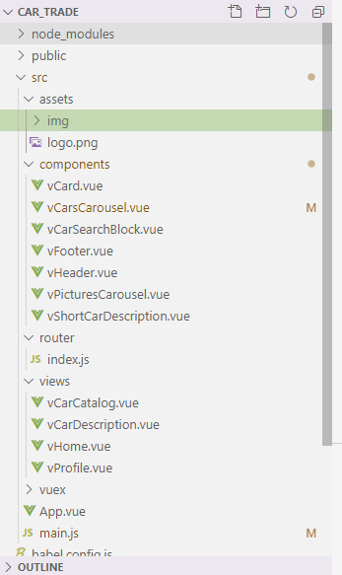

**App.vue**

<template>

  <div *id*="app">

*<!-- Font Awesome -->*

    <link *rel*="stylesheet" *href*="https://use.fontawesome.com/releases/v5.11.2/css/all.css">

    <router-view></router-view>

  </div>

</template>

<script>

import 'bootstrap/dist/css/bootstrap.css'

import 'bootstrap-vue/dist/bootstrap-vue.css'

export default {

  name: 'App',

  components: {

  }

}

</script>

<style>

#app {

  font-family: Avenir, Helvetica, Arial, sans-serif;

  -webkit-font-smoothing: antialiased;

  -moz-osx-font-smoothing: grayscale;

  text-align: left;

  color: #2c3e50;

}

noneBlueLink,

a.linkedCard,

a.linkedCard:hover {

  color: inherit;

  text-decoration: none;

}

.carDescription {

    font-size: 13px;

}

</style>

**vHome.vue**

<template>

    <div *class*="vHome">

        <vHeader/>

        <div *class*="container px-0">

            <div *class*="container px-0">

                <div *class*="row no-gutters pt-3"> *<!--search cars-->*

                    <div *class*="col-9">

                        <vCarSearchBlock/>

                    </div>

                </div>

            </div>

            <h2>Избранное</h2>

            <vCarsCarousel :*cars*="cars"/>

            <h2>Просмотренные</h2>

            <vCarsCarousel :*cars*="cars"/>

        </div>

        <vFooter/>

    </div>

</template>

<script>

    import vHeader from "../components/vHeader"

    import vCarSearchBlock from "../components/vCarSearchBlock"

    import vCarsCarousel from "../components/vCarsCarousel"

    import vFooter from "../components/vFooter"

    export default {

        name: "vHome",

        components: {

            vHeader,

            vCarSearchBlock,

            vCarsCarousel,

            vFooter

        },

**data**() {

            return {

                cars: []

            }

        },

**created**() {

            this.$http.**get**('car/index')

                .**then**((response) => this.cars = response.data)

        }

    }

</script>

vCarCatalog.vue

<template>

    <div *class*="vCarCatalog">

        <vHeader/>

        <div *class*="container px-0">

            <div *class*="row no-gutters pt-3"> *<!--search cars-->*

                <div *class*="col-9">

                    <vCarSearchBlock/>

                    <div *class*="container px-0 mt-4"> *<!--Список объявлений-->*

                        <div *v-for*="car in cars" :*key*="car.id">

                            <hr>

                            <vShortCarDescription :*car*="car"/>

                        </div>

                    </div>

                </div>

            </div>

        </div>

        <vFooter/>

    </div>

</template>

<script>

import vHeader from "../components/vHeader"

import vCarSearchBlock from "../components/vCarSearchBlock"

import vShortCarDescription from "../components/vShortCarDescription"

import vFooter from "../components/vFooter"

export default {

    name: 'vCarCatalog',

    components: {

        vHeader,

        vCarSearchBlock,

        vShortCarDescription,

        vFooter

    },

**data**() {

        return {

            cars: []

        }

    },

**created**() {

        this.$http.**get**('car/index')

            .**then**((response) => this.cars = response.data)

    }

}

</script>

vCarDescription.vue

<template>

    <div *class*="vCarDescription">

        <vHeader/>

        <div *class*="container px-0"> *<!--Main container-->*

            <div *class*="row no-gutters">

                <div *class*="col-9 pr-3"> *<!--Левая часть (Основная часть)-->*

                    <div *class*="row no-gutters"> *<!--Блок краткого описания сверху-->*

                        <div *class*="col-7">

                            <div *class*="row no-gutters "> *<!--Название-->*

                                <h2>Skoda Rapid I</h2>

                            </div>

                            <div *class*="row no-gutters"> *<!--Дополнительная информация-->*

                                <div *class*="row no-gutters d-inline mr-4"> *<!--Дата размещения-->*

                                    15 октября

                                </div>

                                <div *class*="row no-gutters d-inline mr-4"> *<!--Количество просмотров-->*

                                    <i *class*="fas fa-eye"></i> 99 (3 сегодня)

                                </div>

                                <div *class*="row no-gutters d-inline"> *<!--Идентификатор объявления-->*

                                    № 1101262214

                                </div>

                            </div>

                        </div>

                        <div *class*="col-5 text-right"> *<!--Блок цены-->*

                            <div>

                                <h2>567 000 ₽</h2>

                            </div>

                            <div>

                                от 9 700 ₽ / мес

                            </div>

                        </div>

                    </div>

                    <div *class*="row no-gutters my-3"> *<!--Карточка владельца-->*

                        <div *class*="col-6">

                            <div *class*="row no-gutters">

                                <div *class*="col-3 text-center">

                                    <i *class*="fas fa-user-alt"></i>

                                </div>

                                <div *class*="col-9">

                                    Тринити Моторс Эксперт Белгород

                                </div>

                            </div>

                        </div>

                        <div *class*="col-3 py-3 text-center">

                                <i *class*="fas fa-phone"></i> Обратный звонок

                        </div>

                        <div *class*="col-3 py-1 text-center bg-success text-white rounded-right">

                            <div>Показать телефон</div>

                            <div>+7 *** *** ** **</div>

                        </div>

                    </div>

                    <div *class*="row no-gutters"> *<!--Тело объявления-->*

                        <div *class*="col-4 pr-3"> *<!--Левая часть тела объявления-->*

                            <div>

                                <div *class*="row no-gutters">

                                    <div *class*="col-5 text-muted">Год выпуска</div>

                                    <div *class*="col-7">2015</div>

                                </div>

                                <div *class*="row no-gutters">

                                    <div *class*="col-5 text-muted">Пробег</div>

                                    <div *class*="col-7">136 470 км</div>

                                </div>

                                <div *class*="row no-gutters">

                                    <div *class*="col-5 text-muted">Кузов</div>

                                    <div *class*="col-7">Лифтбек</div>

                                </div>

                                <div *class*="row no-gutters">

                                    <div *class*="col-5 text-muted">Цвет</div>

                                    <div *class*="col-7">Белый</div>

                                </div>

                                <div *class*="row no-gutters">

                                    <div *class*="col-5 text-muted">Двигатель</div>

                                    <div *class*="col-7">1.2 л / 75 л.с. / Бензин</div>

                                </div>

                                <div *class*="row no-gutters">

                                    <div *class*="col-5 text-muted">Налог</div>

                                    <div *class*="col-7">1 125 ₽ / год</div>

                                </div>

                                <div *class*="row no-gutters">

                                    <div *class*="col-5 text-muted">Привод</div>

                                    <div *class*="col-7">Передний</div>

                                </div>

                                <div *class*="row no-gutters">

                                    <div *class*="col-5 text-muted">Руль</div>

                                    <div *class*="col-7">Левый</div>

                                </div>

                                <div *class*="row no-gutters">

                                    <div *class*="col-5 text-muted">Состояние</div>

                                    <div *class*="col-7">Не требует ремонта</div>

                                </div>

                                <div *class*="row no-gutters">

                                    <div *class*="col-5 text-muted">Владельцы</div>

                                    <div *class*="col-7">1 владелец</div>

                                </div>

                                <div *class*="row no-gutters">

                                    <div *class*="col-5 text-muted">ПТС</div>

                                    <div *class*="col-7">Оригинал</div>

                                </div>

                                <div *class*="row no-gutters">

                                    <div *class*="col-5 text-muted">Таможня</div>

                                    <div *class*="col-7">Растаможен</div>

                                </div>

                                <div *class*="row no-gutters">

                                    <div *class*="col-5 text-muted">Обмен</div>

                                    <div *class*="col-7">Рассмотрю варианты</div>

                                </div>

                                <div *class*="row no-gutters">

                                    <div *class*="col-5 text-muted">Цвет</div>

                                    <div *class*="col-7">XW8**************</div>

                                </div>

                            </div>

                            <div *class*="bg-success text-white text-center rounded py-2 my-2">

                                Показать VIN

                            </div>

                            <hr>

                            <a *href*="#">Характеристики модели в каталоге</a>

                        </div> *<!--/Левая часть тела объявления-->*

                        <div *class*="col-8"> *<!--Правая часть тела объявления-->*

                            <vPicturesCarousel/>

                            <div> *<!--Комментарий продавца-->*

                                <div *class*="pt-5">

                                    <h3>Комментарий продавца</h3>

                                </div>

                                <div *class*="cut pt-2">

                                    {{comment}}

                                </div>

                            </div>

                            <div> *<!--Комплектация-->*

                                <h3 *class*="pt-3">Комплектация</h3>

                                <div> *<!--Раздел комплектации-->*

                                    <div *class*="container px-0">

                                            <div *class*="row no-gutters justify-content-between" *v-b-toggle*.*collapse-1*>

                                                <div *class*="col-6">Безопасность</div>

                                                <div *class*="col-6 text-right">2</div>

                                            </div>

                                            <hr>

                                            <b-collapse *id*="collapse-1" *class*="mt-3">

                                                <div *class*="row no-gutters">

                                                    <div *class*="col-6 text-muted">

                                                        Подушка безопасности водителя

                                                    </div>

                                                    <div *class*="col-6 text-muted">

                                                        Антиблокировочная система (ABS)

                                                    </div>

                                                </div>

                                            </b-collapse>

                                    </div>

                                </div>

                            </div> *<!--Комплектация-->*

                        </div>

                    </div> *<!--/Тело объявления-->*

                </div>

                <div *class*="col-3"> *<!--Правая часть (колонка для рекламы)-->*

                    Тут должна быть реклама

                </div>

            </div>

        </div>*<!--Main container-->*

        <vFooter/>

    </div>

</template>

<script>

import vHeader from "../components/vHeader"

import vFooter from "../components/vFooter"

import vPicturesCarousel from "../components/vPicturesCarousel"

export default {

    name: 'vCarDescription',

    components: {

        vHeader,

        vFooter,

        vPicturesCarousel

    },

**data**() {

        return {

            comment: "Автомобиль в идеальном состоянии"

        }

    }

}

</script>

# Проектирование БД

Схема базы данных:

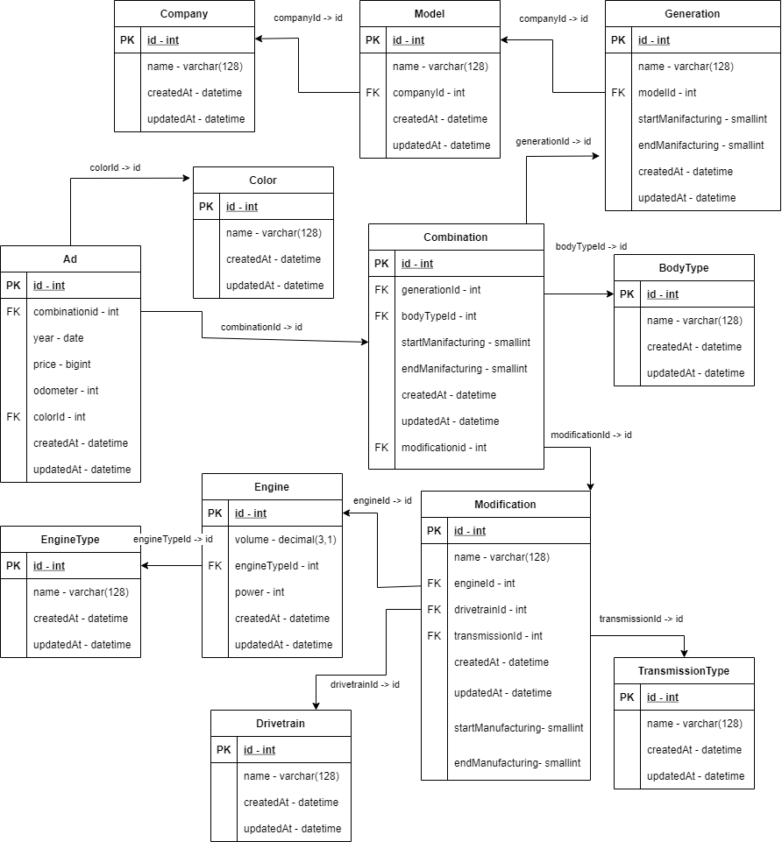

# Создание БД.

Создание таблиц БД осуществляется с помощью миграций.

**Company**

<?php

use yii\db\**Migration**;

*/\*\**

*\* Handles the creation of table `{{%Company}}`.*

*\*/*

class **m210118_182525_create_Company_table** extends **Migration**

{

*/\*\**

*\* {@inheritdoc}*

*\*/*

    public function **safeUp**()

    {

        $this->**createTable**('{{%Company}}', [

            'id' => $this->**primaryKey**(),

            'name' => $this->**string**(128)->**notNull**()->**comment**('Название'),

            'createdAt' => $this->**dateTime**()->**defaultExpression**('now()')->**comment**('Дата создания'),

            'updatedAt' => $this->**dateTime**()->**defaultExpression**('now()')->**comment**('Дата изменения')

        ]);

    }

*/\*\**

*\* {@inheritdoc}*

*\*/*

    public function **safeDown**()

    {

        $this->**dropTable**('{{%Company}}');

    }

}

**Model**

<?php

use yii\db\**Migration**;

*/\*\**

*\* Handles the creation of table `{{%Model}}`.*

*\*/*

class **m210118_182542_create_Model_table** extends **Migration**

{

*/\*\**

*\* {@inheritdoc}*

*\*/*

    public function **safeUp**()

    {

        $this->**createTable**('{{%Model}}', [

            'id' => $this->**primaryKey**(),

            'name' => $this->**string**(128)->**notNull**()->**comment**('Название'),

            'companyId' => $this->**integer**()->**comment**('Компания'),

            'createdAt' => $this->**dateTime**()->**defaultExpression**('now()')->**comment**('Дата создания'),

            'updatedAt' => $this->**dateTime**()->**defaultExpression**('now()')->**comment**('Дата изменения')

        ]);

        $this->**addForeignKey**('fk_Model_companyId',  '{{%Model}}', 'companyId', '{{%Company}}', 'id', 'SET NULL');

    }

*/\*\**

*\* {@inheritdoc}*

*\*/*

    public function **safeDown**()

    {

        $this->**dropForeignKey**('fk_Model_companyId',  '{{%Model}}');

        $this->**dropTable**('{{%Model}}');

    }

}

**BodyType**

<?php

use yii\db\**Migration**;

*/\*\**

*\* Handles the creation of table `{{%BodyType}}`.*

*\*/*

class **m210118_182601_create_BodyType_table** extends **Migration**

{

*/\*\**

*\* {@inheritdoc}*

*\*/*

    public function **safeUp**()

    {

        $this->**createTable**('{{%BodyType}}', [

            'id' => $this->**primaryKey**(),

            'name' => $this->**string**(40)->**notNull**()->**comment**('Название'),

            'createdAt' => $this->**dateTime**()->**defaultExpression**('now()')->**comment**('Дата создания'),

            'updatedAt' => $this->**dateTime**()->**defaultExpression**('now()')->**comment**('Дата изменения')

        ]);

    }

*/\*\**

*\* {@inheritdoc}*

*\*/*

    public function **safeDown**()

    {

        $this->**dropTable**('{{%BodyType}}');

    }

}

**EngineType**

<?php

use yii\db\**Migration**;

*/\*\**

*\* Handles the creation of table `{{%EngineType}}`.*

*\*/*

class **m210118_182619_create_EngineType_table** extends **Migration**

{

*/\*\**

*\* {@inheritdoc}*

*\*/*

    public function **safeUp**()

    {

        $this->**createTable**('{{%EngineType}}', [

            'id' => $this->**primaryKey**(),

            'name' => $this->**string**(100)->**notNull**()->**comment**('Название'),

            'createdAt' => $this->**dateTime**()->**defaultExpression**('now()')->**comment**('Дата создания'),

            'updatedAt' => $this->**dateTime**()->**defaultExpression**('now()')->**comment**('Дата изменения')

        ]);

    }

*/\*\**

*\* {@inheritdoc}*

*\*/*

    public function **safeDown**()

    {

        $this->**dropTable**('{{%EngineType}}');

    }

}

**Engine**

<?php

use yii\db\**Migration**;

*/\*\**

*\* Handles the creation of table `{{%Engine}}`.*

*\*/*

class **m210118_182711_create_Engine_table** extends **Migration**

{

*/\*\**

*\* {@inheritdoc}*

*\*/*

    public function **safeUp**()

    {

        $this->**createTable**('{{%Engine}}', [

            'id' => $this->**primaryKey**(),

            'name' => $this->**string**(100)->**notNull**()->**comment**('Название'),

            'volume' => $this->**decimal**(3,1)->**notNull**()->**comment**('Объем'),

            'engineTypeId' => $this->**integer**()->**comment**('Тип двигателя'),

            'power' => $this->**integer**()->**comment**('Мощность'),

            'createdAt' => $this->**dateTime**()->**defaultExpression**('now()')->**comment**('Дата создания'),

            'updatedAt' => $this->**dateTime**()->**defaultExpression**('now()')->**comment**('Дата изменения')

        ]);

        $this->**addForeignKey**('fk_Engine_engineTypeId', '{{%Engine}}', 'engineTypeId', '{{%EngineType}}', 'id', 'SET NULL');

    }

*/\*\**

*\* {@inheritdoc}*

*\*/*

    public function **safeDown**()

    {

        $this->**dropForeignKey**('fk_Engine_engineTypeId', '{{%Engine}}');

        $this->**dropTable**('{{%Engine}}');

    }

}

**Generation**

<?php

use yii\db\**Migration**;

*/\*\**

*\* Handles the creation of table `{{%Generation}}`.*

*\*/*

class **m210118_182730_create_Generation_table** extends **Migration**

{

*/\*\**

*\* {@inheritdoc}*

*\*/*

    public function **safeUp**()

    {

        $this->**createTable**('{{%Generation}}', [

            'id' => $this->**primaryKey**(),

            'name' => $this->**string**(100)->**notNull**()->**comment**('Название'),

            'modelId' => $this->**integer**()->**comment**('Модель'),

            'startManufacturing' => $this->**smallInteger**()->**notNull**()->**comment**('Начало производства'),

            'endManufacturing' => $this->**smallInteger**()->**comment**('Конец производства'),

            'createdAt' => $this->**dateTime**()->**defaultExpression**('now()')->**comment**('Дата создания'),

            'updatedAt' => $this->**dateTime**()->**defaultExpression**('now()')->**comment**('Дата изменения')

        ]);

        $this->**addForeignKey**('fk_Generation_modelId', '{{%Generation}}', 'modelId', '{{%Model}}', 'id', 'SET NULL');

    }

*/\*\**

*\* {@inheritdoc}*

*\*/*

    public function **safeDown**()

    {

        $this->**dropForeignKey**('fk_Generation_modelId', '{{%Generation}}');

        $this->**dropTable**('{{%Generation}}');

    }

}

**Drivetrain**

<?php

use yii\db\**Migration**;

*/\*\**

*\* Handles the creation of table `{{%Drivetrain}}`.*

*\*/*

class **m210118_182745_create_Drivetrain_table** extends **Migration**

{

*/\*\**

*\* {@inheritdoc}*

*\*/*

    public function **safeUp**()

    {

        $this->**createTable**('{{%Drivetrain}}', [

            'id' => $this->**primaryKey**(),

            'name' => $this->**string**(100)->**comment**('Название'),

            'createdAt' => $this->**dateTime**()->**defaultExpression**('now()')->**comment**('Дата создания'),

            'updatedAt' => $this->**dateTime**()->**defaultExpression**('now()')->**comment**('Дата изменения')

        ]);

    }

*/\*\**

*\* {@inheritdoc}*

*\*/*

    public function **safeDown**()

    {

        $this->**dropTable**('{{%Drivetrain}}');

    }

}

**TransmissionType**

<?php

use yii\db\**Migration**;

*/\*\**

*\* Handles the creation of table `{{%TransmissionType}}`.*

*\*/*

class **m210120_141620_create_TransmissionType_table** extends **Migration**

{

*/\*\**

*\* {@inheritdoc}*

*\*/*

    public function **safeUp**()

    {

        $this->**createTable**('{{%TransmissionType}}', [

            'id' => $this->**primaryKey**(),

            'name' => $this->**string**(128)->**notNull**()->**comment**('Название'),

            'createdAt' => $this->**dateTime**()->**defaultExpression**('now()')->**comment**('Дата создания'),

            'updatedAt' => $this->**dateTime**()->**defaultExpression**('now()')->**comment**('Дата изменения')

        ]);

    }

*/\*\**

*\* {@inheritdoc}*

*\*/*

    public function **safeDown**()

    {

        $this->**dropTable**('{{%TransmissionType}}');

    }

}

**Modification**

<?php

use yii\db\**Migration**;

*/\*\**

*\* Handles the creation of table `{{%Modification}}`.*

*\*/*

class **m210120_141835_create_Modification_table** extends **Migration**

{

*/\*\**

*\* {@inheritdoc}*

*\*/*

    public function **safeUp**()

    {

        $this->**createTable**('{{%Modification}}', [

            'id' => $this->**primaryKey**(),

            'name' => $this->**string**(100)->**notNull**()->**comment**('Название'),

            'drivetrainId' => $this->**integer**()->**comment**('Привод'),

            'engineId' => $this->**integer**()->**comment**('Двигатель'),

            'transmissionId' => $this->**integer**()->**comment**('Коробка передач'),

            'startManufacturing' => $this->**smallInteger**()->**notNull**()->**comment**('Начало производства'),

            'endManufacturing' => $this->**smallInteger**()->**comment**('Конец производства'),

            'createdAt' => $this->**dateTime**()->**defaultExpression**('now()')->**comment**('Дата создания'),

            'updatedAt' => $this->**dateTime**()->**defaultExpression**('now()')->**comment**('Дата изменения')

        ]);

        $this->**addForeignKey**('fk_Modificaton_drivetrainId','{{%Modification}}', 'drivetrainId', '{{%Drivetrain}}', 'id', 'SET NULL');

        $this->**addForeignKey**('fk_Modification_engineId', '{{%Modification}}', 'engineId', '{{%Engine}}', 'id', 'SET NULL');

        $this->**addForeignKey**('fk_Modification_transmissionId', '{{%Modification}}', 'transmissionId', '{{%TransmissionType}}', 'id', 'SET NULL');

    }

*/\*\**

*\* {@inheritdoc}*

*\*/*

    public function **safeDown**()

    {

        $this->**dropForeignKey**('fk_Modification_transmissionId', '{{%Modification}}');

        $this->**dropForeignKey**('fk_Modification_engineId', '{{%Modification}}');

        $this->**dropForeignKey**('fk_Modificaton_drivetrainId','{{%Modification}}');

        $this->**dropTable**('{{%Modification}}');

    }

}

**Combination**

<?php

use yii\db\**Migration**;

*/\*\**

*\* Handles the creation of table `{{%Combination}}`.*

*\*/*

class **m210120_141913_create_Combination_table** extends **Migration**

{

*/\*\**

*\* {@inheritdoc}*

*\*/*

    public function **safeUp**()

    {

        $this->**createTable**('{{%Combination}}', [

            'id' => $this->**primaryKey**(),

            'generationId' => $this->**integer**()->**comment**('Поколение'),

            'bodyTypeId' => $this->**integer**()->**comment**('Тип кузова'),

            'modificationId' => $this->**integer**()->**comment**('Модификация'),

            'createdAt' => $this->**dateTime**()->**defaultExpression**('now()')->**comment**('Дата создания'),

            'updatedAt' => $this->**dateTime**()->**defaultExpression**('now()')->**comment**('Дата изменения')

        ]);

        $this->**addForeignKey**('fk_Combination_generationId', '{{%Combination}}', 'generationId',

                            '{{%Generation}}', 'id', 'SET NULL');

        $this->**addForeignKey**('fk_Combination_bodyTypeId', '{{%Combination}}', 'bodyTypeId',

                            '{{%BodyType}}', 'id', 'SET NULL');

        $this->**addForeignKey**('fk_Combination_modificationId', '{{%Combination}}', 'modificationId',

                            '{{%Modification}}', 'id', 'SET NULL');

    }

*/\*\**

*\* {@inheritdoc}*

*\*/*

    public function **safeDown**()

    {

        $this->**dropForeignKey**('fk_Combination_modificationId', '{{%Combination}}');

        $this->**dropForeignKey**('fk_Combination_bodyTypeId', '{{%Combination}}');

        $this->**dropForeignKey**('fk_Combination_generationId', '{{%Combination}}');

        $this->**dropTable**('{{%Combination}}');

    }

}

**Color**

<?php

use yii\db\**Migration**;

*/\*\**

*\* Handles the creation of table `{{%Color}}`.*

*\*/*

class **m210120_141945_create_Color_table** extends **Migration**

{

*/\*\**

*\* {@inheritdoc}*

*\*/*

    public function **safeUp**()

    {

        $this->**createTable**('{{%Color}}', [

            'id' => $this->**primaryKey**(),

            'name' => $this->**string**(50)->**comment**('Название'),

            'createdAt' => $this->**dateTime**()->**defaultExpression**('now()')->**comment**('Дата создания'),

            'updatedAt' => $this->**dateTime**()->**defaultExpression**('now()')->**comment**('Дата изменения')

        ]);

    }

*/\*\**

*\* {@inheritdoc}*

*\*/*

    public function **safeDown**()

    {

        $this->**dropTable**('{{%Color}}');

    }

}

**Ad**

<?php

use yii\db\**Migration**;

*/\*\**

*\* Handles the creation of table `{{%Ad}}`.*

*\*/*

class **m210120_142024_create_Ad_table** extends **Migration**

{

*/\*\**

*\* {@inheritdoc}*

*\*/*

    public function **safeUp**()

    {

        $this->**createTable**('{{%Ad}}', [

            'id' => $this->**primaryKey**(),

            'combinationId' => $this->**integer**()->**comment**('Комбинация'),

            'year' => $this->**date**()->**notNull**()->**comment**('Год'),

            'price' => $this->**bigInteger**()->**notNull**()->**comment**('Цена'),

            'odometer' => $this->**integer**()->**notNull**()->**comment**('Пробег'),

            'colorId' => $this->**integer**()->**comment**('Цвет'),

            'countOwners' => $this->**integer**()->**notNull**()->**comment**('Количество владельцев'),

            'createdAt' => $this->**dateTime**()->**defaultExpression**('now()')->**comment**('Дата создания'),

            'updatedAt' => $this->**dateTime**()->**defaultExpression**('now()')->**comment**('Дата изменения')

        ]);

        $this->**addForeignKey**('fk_Ad_combinationId', '{{%Ad}}', 'combinationId',

                                                    '{{%Combination}}', 'id', 'SET NULL');

        $this->**addForeignKey**('fk_Ad_colorId', '{{%Ad}}', 'colorId',

                                                    '{{%Color}}', 'id', 'SET NULL');

    }

*/\*\**

*\* {@inheritdoc}*

*\*/*

    public function **safeDown**()

    {

        $this->**dropForeignKey**('fk_Ad_colorId', '{{%Ad}}');

        $this->**dropForeignKey**('fk_Ad_combinationId', '{{%Ad}}');

        $this->**dropTable**('{{%Ad}}');

    }

}

**AdImage**

<?php

use yii\db\**Migration**;

*/\*\**

*\* Handles the creation of table `{{%AdImage}}`.*

*\*/*

class **m210123_184934_create_AdImage_table** extends **Migration**

{

*/\*\**

*\* {@inheritdoc}*

*\*/*

    public function **safeUp**()

    {

        $this->**createTable**('{{%AdImage}}', [

            'id' => $this->**primaryKey**(),

            'adId' => $this->**integer**()->**comment**('Объявление'),

            'picNumber' => $this->**integer**()->**comment**('Номер картинки в объявлении')

        ]);

        $this->**addForeignKey**('fk_AdImage_adId', '{{%AdImage}}', 'adId',

                                                '{{%Ad}}'     , 'id', 'SET NULL');

    }

*/\*\**

*\* {@inheritdoc}*

*\*/*

    public function **safeDown**()

    {

        $this->**dropForeignKey**('fk_AdImage_adId', '{{%AdImage}}');

        $this->**dropTable**('{{%AdImage}}');

    }

}

# Создание REST API

**Описание методов API**

Базовый URL: http://localhost:8080/api/v1

---Объявление:

1. Добавление объявления

URL: /ad/add

Тип запроса: POST

Параметры: body - объект Ad

1. Получение списка объявлений.

URL: /ad

Тип запроса: GET

Параметры: нет

---Цвет:

1. Добавление цвета авто

URL: /color/add

Тип запроса: POST

Параметры: body - объект Color

---Тип кузова:

1. Добавление типа кузова

URL: /body-type/add

Тип запроса: POST

Параметры: body - объект BodyType

1. Получение типов кузовов, возможные для данной модели в данном году.

URL: /body-type/by-model-year

Тип запроса: POST

Параметры:

|  |  |  |  |
| --- | --- | --- | --- |
| Название | Описание | Тип | Обязательный? |
| modelId | Модель авто | Integer | да |
| year | Год автомобиля | Integer | да |

---Компания:

1. Добавление компании.

URL: /company/add

Тип запроса: POST

Параметры: body - объект Company

---Модель:

1. Добавление модели авто.

URL: /model/add

Тип запроса: POST

Параметры: body - объект Model

1. Получение списка годов производства определенной модели.

URL: /model/get-manufacturing-years

Тип запроса: GET

Параметры:

|  |  |  |  |
| --- | --- | --- | --- |
| Название | Описание | Тип | Обязательный? |
| id | Модель | Integer | да |

1. Получение моделей определенной компании.

URL: /model/by-company

Тип запроса: GET

Параметры:

|  |  |  |  |
| --- | --- | --- | --- |
| Название | Описание | Тип | Обязательный? |
| companyId | Компания | Integer | да |

---Трансмиссия:?

1. Добавление типа трансмиссии.

URL: /transmission-type/add

Тип запроса: POST

Параметры: body - объект TransmissionType

1. Получение списка типов двигателей по поколению, типу кузова и году.

URL: /transmission-type/by-gen-body-year

Тип запроса: GET

Параметры:

|  |  |  |  |
| --- | --- | --- | --- |
| Название | Описание | Тип | Обязательный? |
| generationId | Поколение | Int | да |
| bodyTypeId | Типа кузова | Int | да |
| year | Год авто | Int | Да |

---Тип двигателя:?

1. Добавлении типа двигателя.

URL: /engine-type/add

Тип запроса: POST

Параметры: body - объект EngineType

---Двигатель:

1. Добавление двигателя.

URL: /engine/add

Тип запроса: POST

Параметры: body - объект Engine

---Модификация:

1. Добавление модификации

URL: /modification/add

Тип запроса: POST

Параметры: body - объект Modification

1. Получение списка модификаций.

URL: /modification

Тип запроса: GET

Параметры:

|  |  |  |  |
| --- | --- | --- | --- |
| Название | Описание | Тип | Обязательный? |
| generationId | Поколение | Int | да |
| bodyTypeId | Типа кузова | Int | да |
| year | Год авто | Int | Да |
| engineTypeId | Тип двигателя | Int | нет |
| drivetrainId | Тип привода | int | нет |

---Поколение:

1. Добавление поколения автомобиля

URL: /generation/add

Тип запроса: POST

Параметры: body - объект Generation

---Комбинация:

1. Добавление комбинации (полный состав) автомобиля.

URL: /combination/add

Тип запроса: POST

Параметры: body - объект Combination

1. Получение комбинации для определенного поколения, модификации и типа кузова.

URL: /combination/by-generation-body-modification

Тип запроса: GET

Параметры:

|  |  |  |  |
| --- | --- | --- | --- |
| Название | Описание | Тип | Обязательный? |
| generationId | Поколение | Int | да |
| bodyTypeId | Типа кузова | Int | да |
| modificationId | Модификация | Int | Да |

**Реализация API**

API реализован на основе контроллеров фреймворка yii (yii\rest\Controller).

Для начала, создадим базовый контроллер, в котором разрешим кросс-доменные запросы. От данного контроллера будем наследовать все остальные контроллеры.

**ApiController**

<?php

namespace **app\modules\v1\controllers**;

use yii\rest\**Controller**;

use yii\filters\auth\**CompositeAuth**;

use yii\filters\**ContentNegotiator**;

use yii\filters\**Cors**;

use yii\filters\**RateLimiter**;

use yii\filters\**VerbFilter**;

use yii\web\**Response**;

class **ApiController** extends **Controller**

{

    public function **behaviors**()

    {

        return [

            'contentNegotiator' => [

                'class' => **ContentNegotiator**::**className**(),

                'formats' => [

                    'application/json' => **Response**::FORMAT_JSON

                ],

            ],

            'verbFilter' => [

                'class' => **VerbFilter**::**className**(),

                'actions' => $this->**verbs**(),

            ],

            'authenticator' => [

                'class' => **CompositeAuth**::**className**(),

            ],

            'rateLimiter' => [

                'class' => **RateLimiter**::**className**(),

            ],

            'corsFilter' => [

                'class' => **Cors**::class

            ]

        ];

    }

}

**AdController**

<?php

namespace **app\modules\v1\controllers**;

use app\modules\v1\models\**Ad**;

use **Yii**;

class **AdController** extends **ApiController**

{

    public function **actionIndex**()

    {

    }

    public function **actionAdd**() {

        $model = new **Ad**();

        $model->**load**(**Yii**::$app->request->**getBodyParams**(), '');

        $model->**save**();

        return $model;

    }

}

**BodyTypeController**

<?php

namespace **app\modules\v1\controllers**;

use app\modules\v1\models\**BodyType**;

use app\modules\v1\models\**Model**;

use **Yii**;

class **BodyTypeController** extends **ApiController**

{

    public function **actionIndex**()

    {

    }

    public function **actionAdd**() {

        $model = new **BodyType**();

        $model->**load**(**Yii**::$app->request->**getBodyParams**(), '');

        $model->**save**();

        return $model;

    }

*//Подумать, могу ли я это сделать проще(С помощью ActiveRecord и groupBy)*

    public function **actionByModelYear**($modelId, $year) {

*/*$generations = Model::findOne($modelId)->getGenerations()*

*->where(['<=', 'startManufacturing', $year])*

*->andWhere(['>=', 'endManufacturing', $year])*

*->joinWith('combinations')*

*->all();*

*BodyType::find()*

*->joinWith('combinations')*

*->all();*

*\*/*

        $generations = **Model**::**findOne**($modelId)->**getGenerations**()

            ->**where**(['<=', 'startManufacturing', $year])

            ->**andWhere**(['>=', 'endManufacturing', $year])

            ->**all**();

        $bodyTypes = [];

        foreach ($generations as $generation) {

            foreach ($generation->combinations as $combination) {

                if(!**in_array**($combination->bodyTypeId, $bodyTypes)) {

                    $bodyTypes[] = $combination->bodyTypeId;

                }

            }

        }

        return **BodyType**::**findAll**($bodyTypes);

    }

}

**CarController**

<?php

namespace **app\modules\v1\controllers**;

use app\modules\v1\models\**Ad**;

class **CarController** extends **ApiController**

{

    public function **actionIndex**()

    {

*//return 'list';*

        $ad = **Ad**::**find**()

            ->**orderBy**(['createdAt' => SORT_DESC])

            ->**all**();

        return $ad;

    }

    public function **actionCompanyAdd**() {

        return 'company-add';

    }

    public function **actionList**($id) {

        $ad = **Ad**::**find**()

            ->**where**(['id' => $id])

            ->**one**();

        return $ad;

    }

    public function **actionImagesNames**() {

    }

}

**ColorController**

<?php

namespace **app\modules\v1\controllers**;

use app\modules\v1\models\**Color**;

use **Yii**;

class **ColorController** extends **ApiController**

{

    public function **actionIndex**()

    {

    }

    public function **actionAdd**() {

        $model = new **Color**();

        $model->**load**(**Yii**::$app->request->**getBodyParams**(), '');

        $model->**save**();

        return $model;

    }

}

**CombinationController**

<?php

namespace **app\modules\v1\controllers**;

use app\modules\v1\models\**Combination**;

use **Yii**;

class **CombinationController** extends **ApiController**

{

    public function **actionIndex**()

    {

    }

    public function **actionAdd**() {

        $model = new **Combination**();

        $model->**load**(**Yii**::$app->request->**getBodyParams**(), '');

        $model->**save**();

        return $model;

    }

    public function **actionByGenerationBodyModification**($generationId, $bodyTypeId, $modificationId)

    {

        return

**Combination**::**findOne**([

                    'generationId' => $generationId,

                    'bodyTypeId' => $bodyTypeId,

                    'modificationId' => $modificationId

                ]);

    }

}

**CompanyController**

<?php

namespace **app\modules\v1\controllers**;

use app\modules\v1\models\**Company**;

use **Yii**;

class **CompanyController** extends **ApiController**

{

    public function **actionIndex**()

    {

        return **Company**::**find**()->**all**();

    }

    public function **actionAdd**() {

        $model = new **Company**();

        $model->**load**(**Yii**::$app->request->**getBodyParams**(), '');

        $model->**save**();

        return $model;

    }

    public function **actionModels**($id) {

        return **Company**::**findOne**($id)->**getModels**()->**all**();

    }

}

**DrivetrainController**

<?php

namespace **app\modules\v1\controllers**;

use app\modules\v1\models\**BodyType**;

use app\modules\v1\models\**Combination**;

use app\modules\v1\models\**Drivetrain**;

use app\modules\v1\models\**Modification**;

use **Yii**;

class **DrivetrainController** extends **ApiController**

{

    public function **actionIndex**()

    {

    }

    public function **actionAdd**() {

        $model = new **Drivetrain**();

        $model->**load**(**Yii**::$app->request->**getBodyParams**(), '');

        $model->**save**();

        return $model;

    }

    public function **actionByGenBodyYearEngineType**($generationId, $bodyTypeId, $year, $engineTypeId) {

        $modifications = **Modification**::**getModifications**($generationId, $bodyTypeId, $year, $engineTypeId)

                            ->**all**();

        $drivetrains = [];

        foreach($modifications as $modification) {

            if(!**in_array**($modification->drivetrain->id, $drivetrains)) {

                $drivetrains[] = $modification->drivetrain->id;

            }

        }

        return **Drivetrain**::**findAll**($drivetrains);

    }

}

**EngineController**

<?php

namespace **app\modules\v1\controllers**;

use app\modules\v1\models\**Engine**;

use **Yii**;

class **EngineController** extends **ApiController**

{

    public function **actionIndex**()

    {

    }

    public function **actionAdd**() {

        $model = new **Engine**();

        $model->**load**(**Yii**::$app->request->**getBodyParams**(), '');

        $model->**save**();

        return $model;

    }

}

**EngineTypeController**

<?php

namespace **app\modules\v1\controllers**;

use app\modules\v1\models\**EngineType**;

use app\modules\v1\models\**Modification**;

use **Yii**;

class **EngineTypeController** extends **ApiController**

{

    public function **actionIndex**()

    {

        return 'tut';

    }

    public function **actionAdd**() {

        $model = new **EngineType**();

        $model->**load**(**Yii**::$app->request->**getBodyParams**(), '');

        $model->**save**();

        return $model;

    }

    public function **actionByGenBodyYear**($generationId, $bodyTypeId, $year) {

        $modifications = **Modification**::**getModifications**($generationId, $bodyTypeId, $year)

                            ->**all**();

        $engineTypes = [];

        foreach($modifications as $modification) {

            if(!**in_array**($modification->engine->engineType->id, $engineTypes)) {

                $engineTypes[] = $modification->engine->engineType->id;

            }

        }

        return **EngineType**::**findAll**($engineTypes);

    }

}

**GenerationController**

<?php

namespace **app\modules\v1\controllers**;

use app\modules\v1\models\**Generation**;

use app\modules\v1\models\**Model**;

use app\modules\v1\models\**Combination**;

use app\modules\v1\models\**BodyType**;

use **Yii**;

class **GenerationController** extends **ApiController**

{

    public function **actionIndex**()

    {

    }

    public function **actionAdd**() {

        $model = new **Generation**();

        $model->**load**(**Yii**::$app->request->**getBodyParams**(), '');

        $model->**save**();

        return $model;

    }

    public function **actionByModelYearBody**($modelId, $year, $bodyTypeId ) {

        $generations = **Model**::**findOne**($modelId)->**getGenerations**()

            ->**where**(['<=', 'startManufacturing', $year])

            ->**andWhere**(['>=', 'endManufacturing', $year])

            ->**joinWith**('combinations')

            ->**andWhere**(['bodyTypeId' => $bodyTypeId])

            ->**all**();

        return $generations;

    }

}

**ImagesController**

<?php

namespace **app\modules\v1\controllers**;

use app\modules\v1\models\**AdImage**;

use **Yii**;

class **ImagesController** extends **ApiController**

{

    public function **actionIndex**($id)

    {

        $adImage = **AdImage**::**findOne**($id);

        $picPath = '/app/assets/images/ad/' . $adImage->adId . '/' . $adImage->picNumber.'.webp';

        return \**Yii**::$app->**getResponse**()->**sendFile**($picPath, null, [

            'mimeType' => 'image/png',

            'inline' => true,

        ]);

    }

*/\**

*public function actionIndex()*

*{*

*return \Yii::$app->getResponse()->sendFile('/app/logo.png', null, [*

*'mimeType' => 'image/png',*

*'inline' => true,*

*]);*

*}*/*

    public function **actionGetListImagesByAd**($adId)

    {

        return **AdImage**::**getImagesByAd**($adId);

    }

}

**ModelController**

<?php

namespace **app\modules\v1\controllers**;

use app\modules\v1\models\**Model**;

use app\modules\v1\models\**Generation**;

use app\modules\v1\models\**Combination**;

use app\modules\v1\models\**BodyType**;

use app\modules\v1\models\**Company**;

use **Yii**;

class **ModelController** extends **ApiController**

{

    public function **actionIndex**()

    {

    }

    public function **actionAdd**() {

        $model = new **Model**();

        $model->**load**(**Yii**::$app->request->**getBodyParams**(), '');

        $model->**save**();

        return $model;

    }

    public function **actionGetManufacturingYears**($id) {

        $generations = **Model**::**findOne**($id)->**getGenerations**()->**all**();

        $years = [];

        foreach ($generations as $generation) {

            $startYear = $generation->startManufacturing;

            $endYear = $generation->endManufacturing;

            for($i=$startYear; $i < $endYear; $i++) {

                if(!**in_array**($i, $years)) {

                    $years[] = $i;

                }

            }

        }

**usort**($years, function($a, $b){

            return ($a - $b);

        });

        return $years;

    }

    public function **actionByCompany**($id) {

        return **Company**::**findOne**($id)->models;

    }

}

**ModificationController**

<?php

namespace **app\modules\v1\controllers**;

use app\modules\v1\models\**Modification**;

use app\modules\v1\models\**Combination**;

use app\modules\v1\models\**Generation**;

use **Yii**;

class **ModificationController** extends **ApiController**

{

    public function **actionIndex**($generationId, $bodyTypeId, $year, $engineTypeId, $drivetrainId)

    {

        return **Modification**::**getModifications**($generationId, $bodyTypeId, $year, $engineTypeId, $drivetrainId) -> **all**();

    }

    public function **actionAdd**() {

        $model = new **Modification**();

        $model->**load**(**Yii**::$app->request->**getBodyParams**(), '');

        $model->**save**();

        return $model;

    }

}

**Использование http запросов**

Для отправки http запросов используется библиотека axios.

В файле main.js создается объект Axios. с помощью которого производится обращение к методам API. При создании указывается базовый URL, к которому будет добавлять URI метода определенного контроллера при вызове методов http.

import Axios from "axios"

**Vue**.prototype.$http = Axios.**create**({

  baseURL: 'http://localhost:1199/v1'

});

Пример использования:

<template>

    <div *class*="vCarCatalog">

        <vHeader/>

        <div *class*="container px-0">

            <div *class*="row no-gutters pt-3"> *<!--search cars-->*

                <div *class*="col-9">

                    <vCarSearchBlock/>

                    <div *class*="container px-0 mt-4"> *<!--Список объявлений-->*

                        <div *v-for*="car in cars" :*key*="car.id">

                            <hr>

                            <vShortCarDescription :*car*="car"/>

                        </div>

                    </div>

                </div>

            </div>

        </div>

        <vFooter/>

    </div>

</template>

<script>

import vHeader from "../components/vHeader"

import vCarSearchBlock from "../components/vCarSearchBlock"

import vShortCarDescription from "../components/vShortCarDescription"

import vFooter from "../components/vFooter"

export default {

    name: 'vCarCatalog',

    components: {

        vHeader,

        vCarSearchBlock,

        vShortCarDescription,

        vFooter

    },

**data**() {

        return {

            cars: []

        }

    },

**created**() {

        this.$http.**get**('car')

            .**then**((response) => {

                this.cars = response.data;

            });

    }

}

</script>

В теге <script> а хуке created вызывается метод get с параметром ‘car’. Произойдет обращение к контроллеру car и методу index.

В случае успешного результат, отработает функция, указанная в методе then и мы присвоим переменной this.cars данные ответа запроса.

Сработает реактивность VueJS и данные отобразятся на посредством компонентов vShortCarDescription, в который мы передаем элементы массива this.cars.

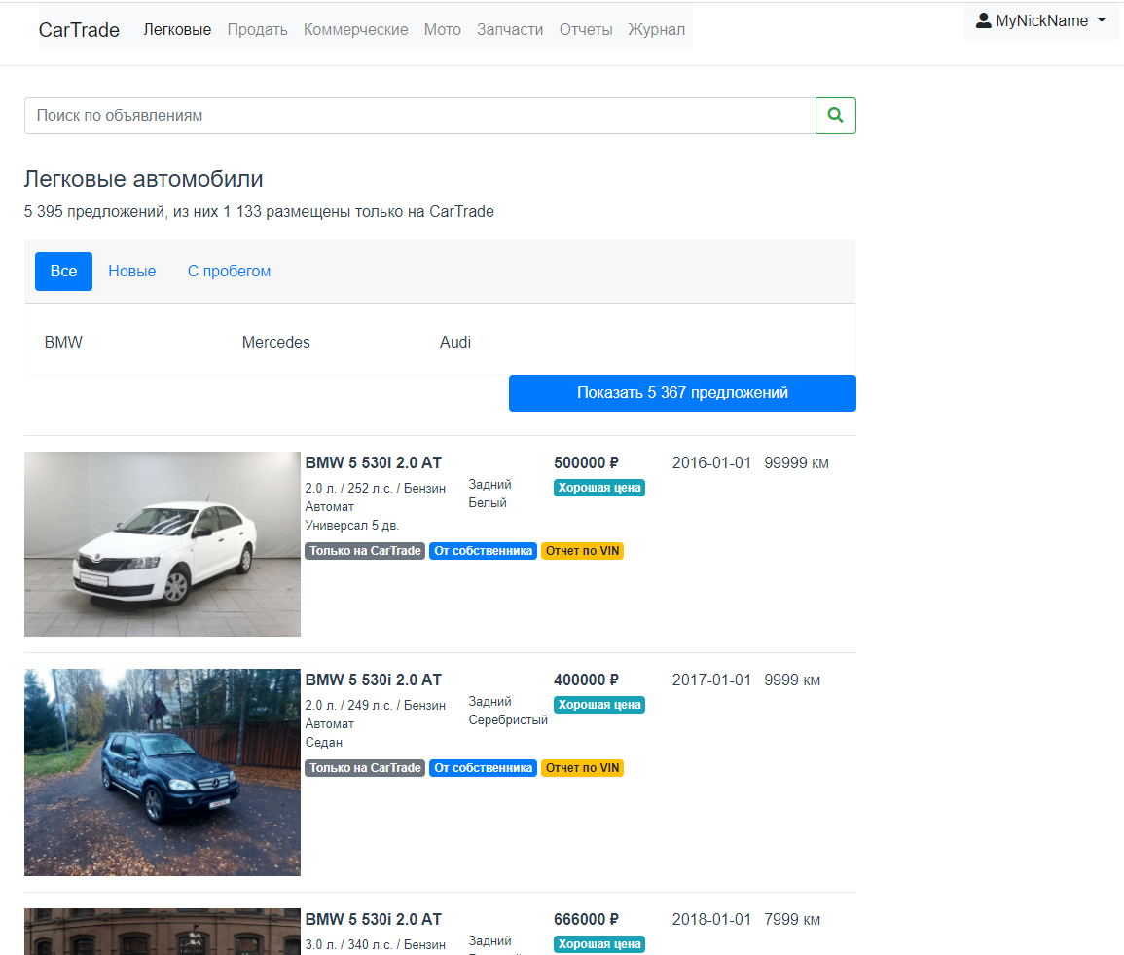

На данной картинке отображается в виде списка с кратким описание автомобиля.

# Вывод:

В результате выполнения данной работы нам удалось создать полноценное веб-приложение, которое позволяет просматривать автомобильные объявления. Сначала мы сверстали шаблоны с использование HTML, CSS и Bootstrap. Затем написали клиентское приложение с использованием VueJS. Создали REST API и спроектировали БД, используя для всего Yii, а в качестве СУБД MySQL. А в конце связали бэкенд и фронтенд, взяв за основу библиотеку Axios.